**Progression Documentation – Website Development**

**P14184295 – Sukhwinder Singh**

1. **Items utilised:**

* Photoshop
* HTML5
* CSS3
* JavaScript
* Bootstrap
* Flickr API

1. **Github Setup**

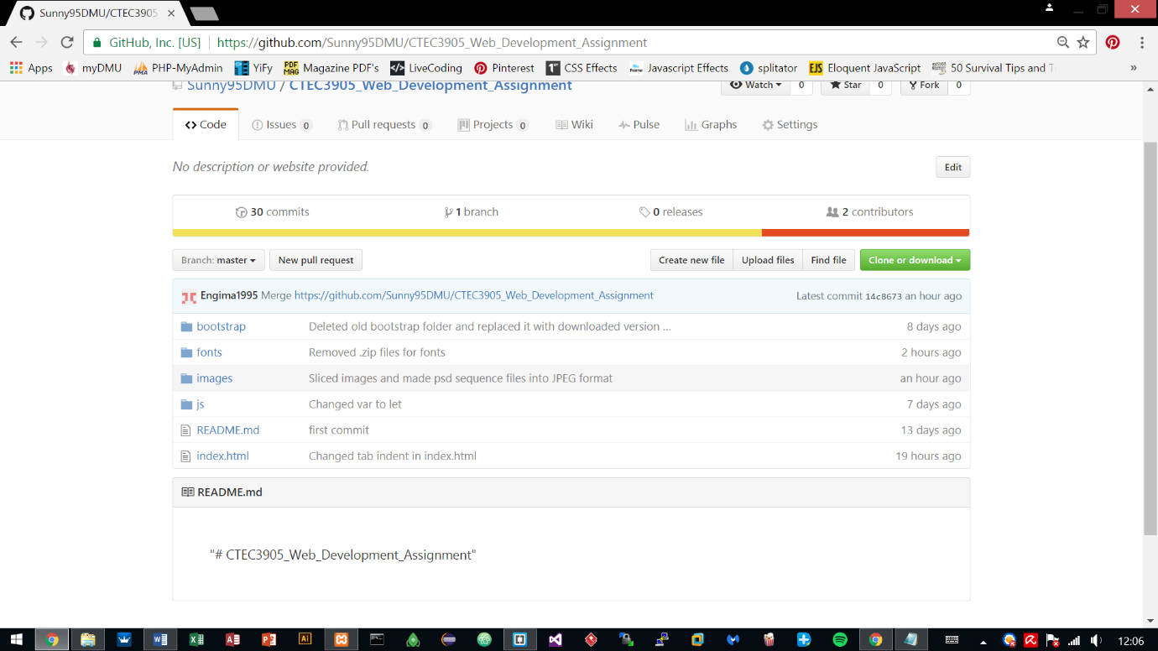The first step included signing up to Github and making a public account on Sunny95DMU with the repository CTEC3905_Web_Development_Assignment.

A copy of the repository stored on GitHub was downloaded/initialised as .git local repository on the local machine for pulling and pushing any changes to the development work on to the Github repository.

The structure of the folders and files are listed below and they represent the progress that has been made to the development for the past few weeks.

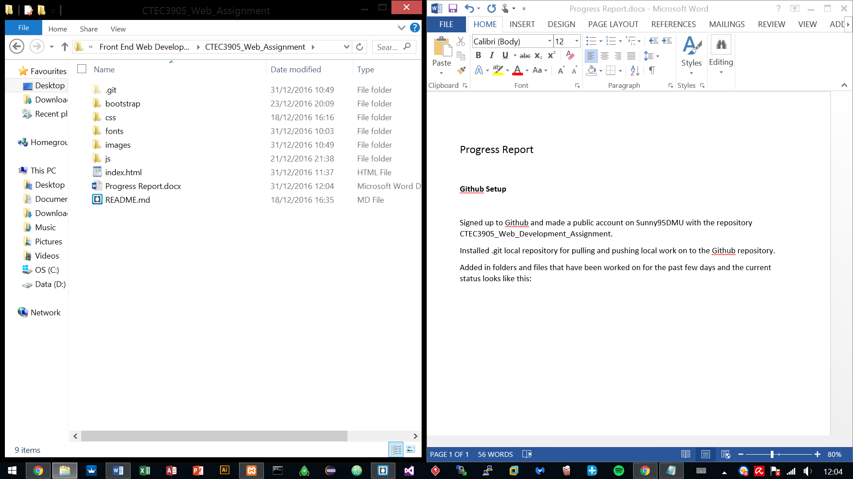

1. **Fetching Flickr data with JSON**

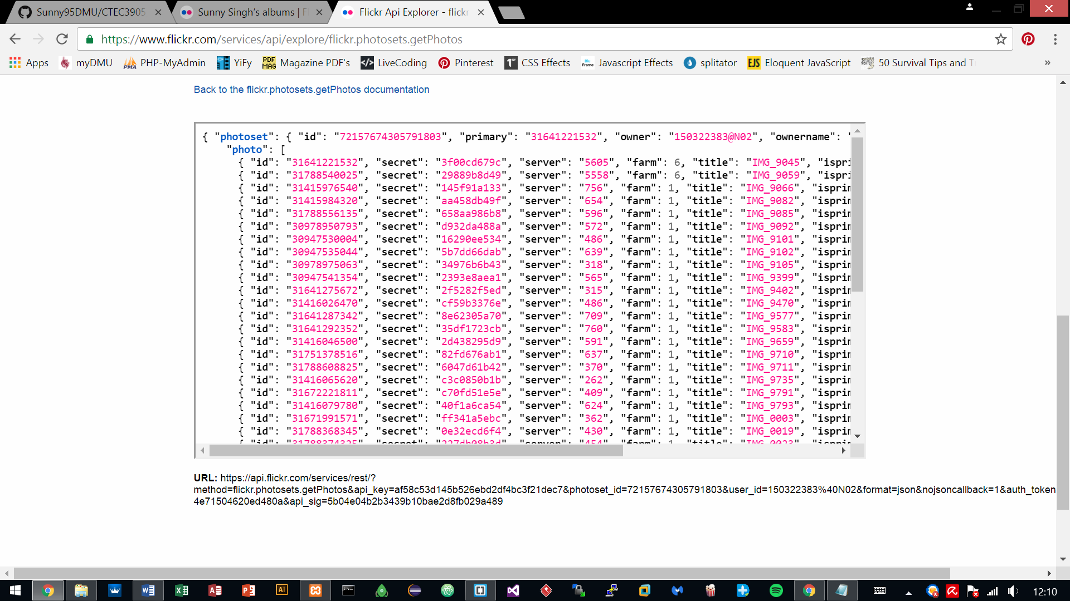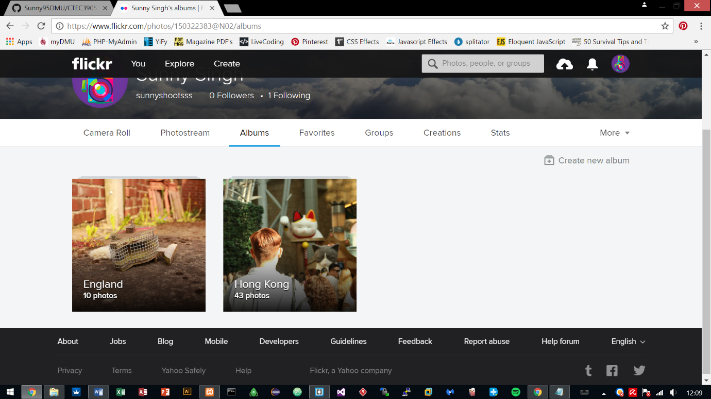This progress shows the uploading of the images to Flickr and utilising Flickr API to retrieve those uploaded images via JSON, to show them categorically within the website pages.

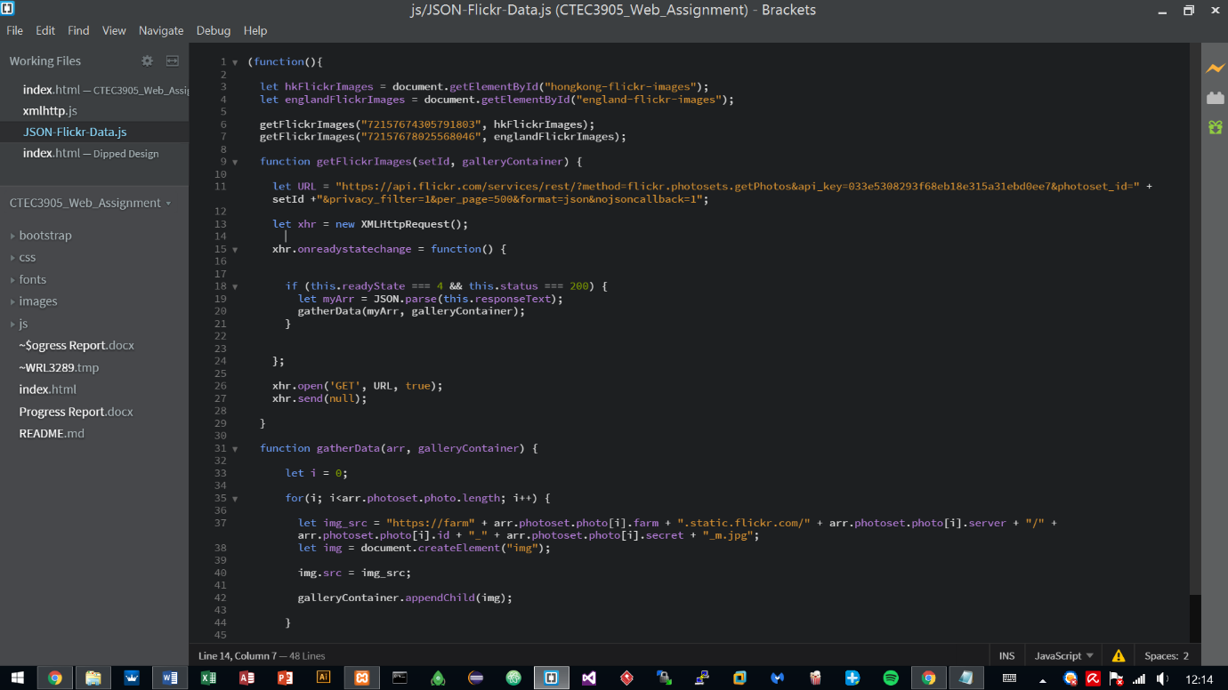The API key provided by the Flickr site was used with JSON formatting for connecting to the Flickr server. This in return gave an array of the uploaded images, which is stored in their own separate sections representing the country album title.

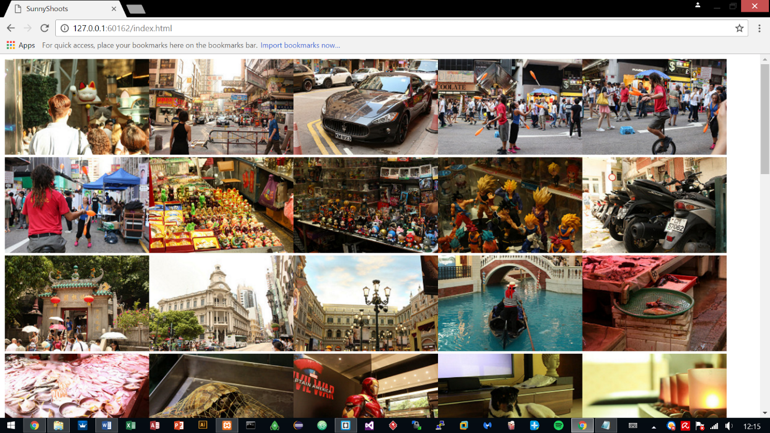

1. **Created Interface design**

After testing the JSON formatting and having the results returned back successfully, it was time to move on to the interface design.

The website is based on a photography portfolio hence why importing the images using vanilla JavaScript JSON format was important.

The website was done in Photoshop and took 2 days to finish the interface, altogether 8 hours were put into it.

**4.1 Sequence 1 – Index Page**

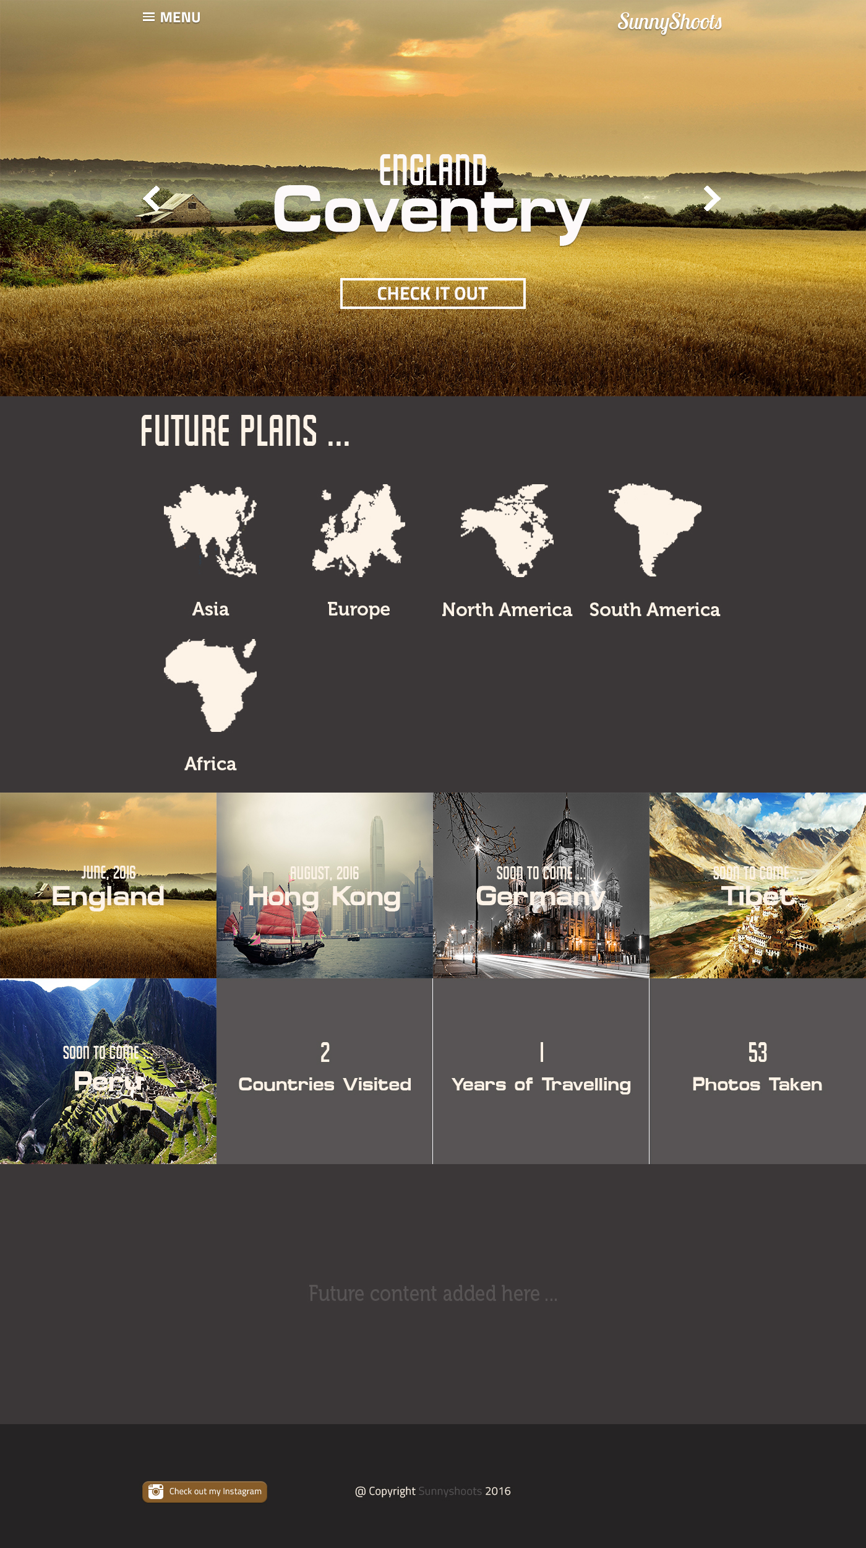

**4.2 Sequence 2 – Opening Menu**

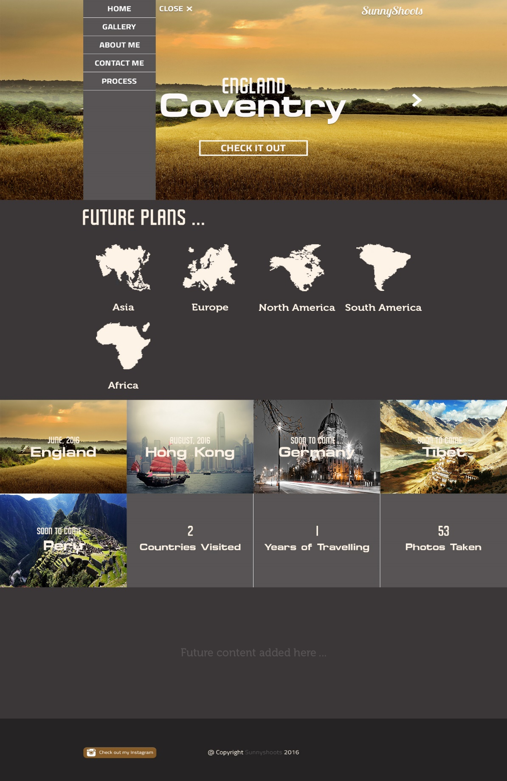

**4.3 Sequence 3 – Gallery Tab**

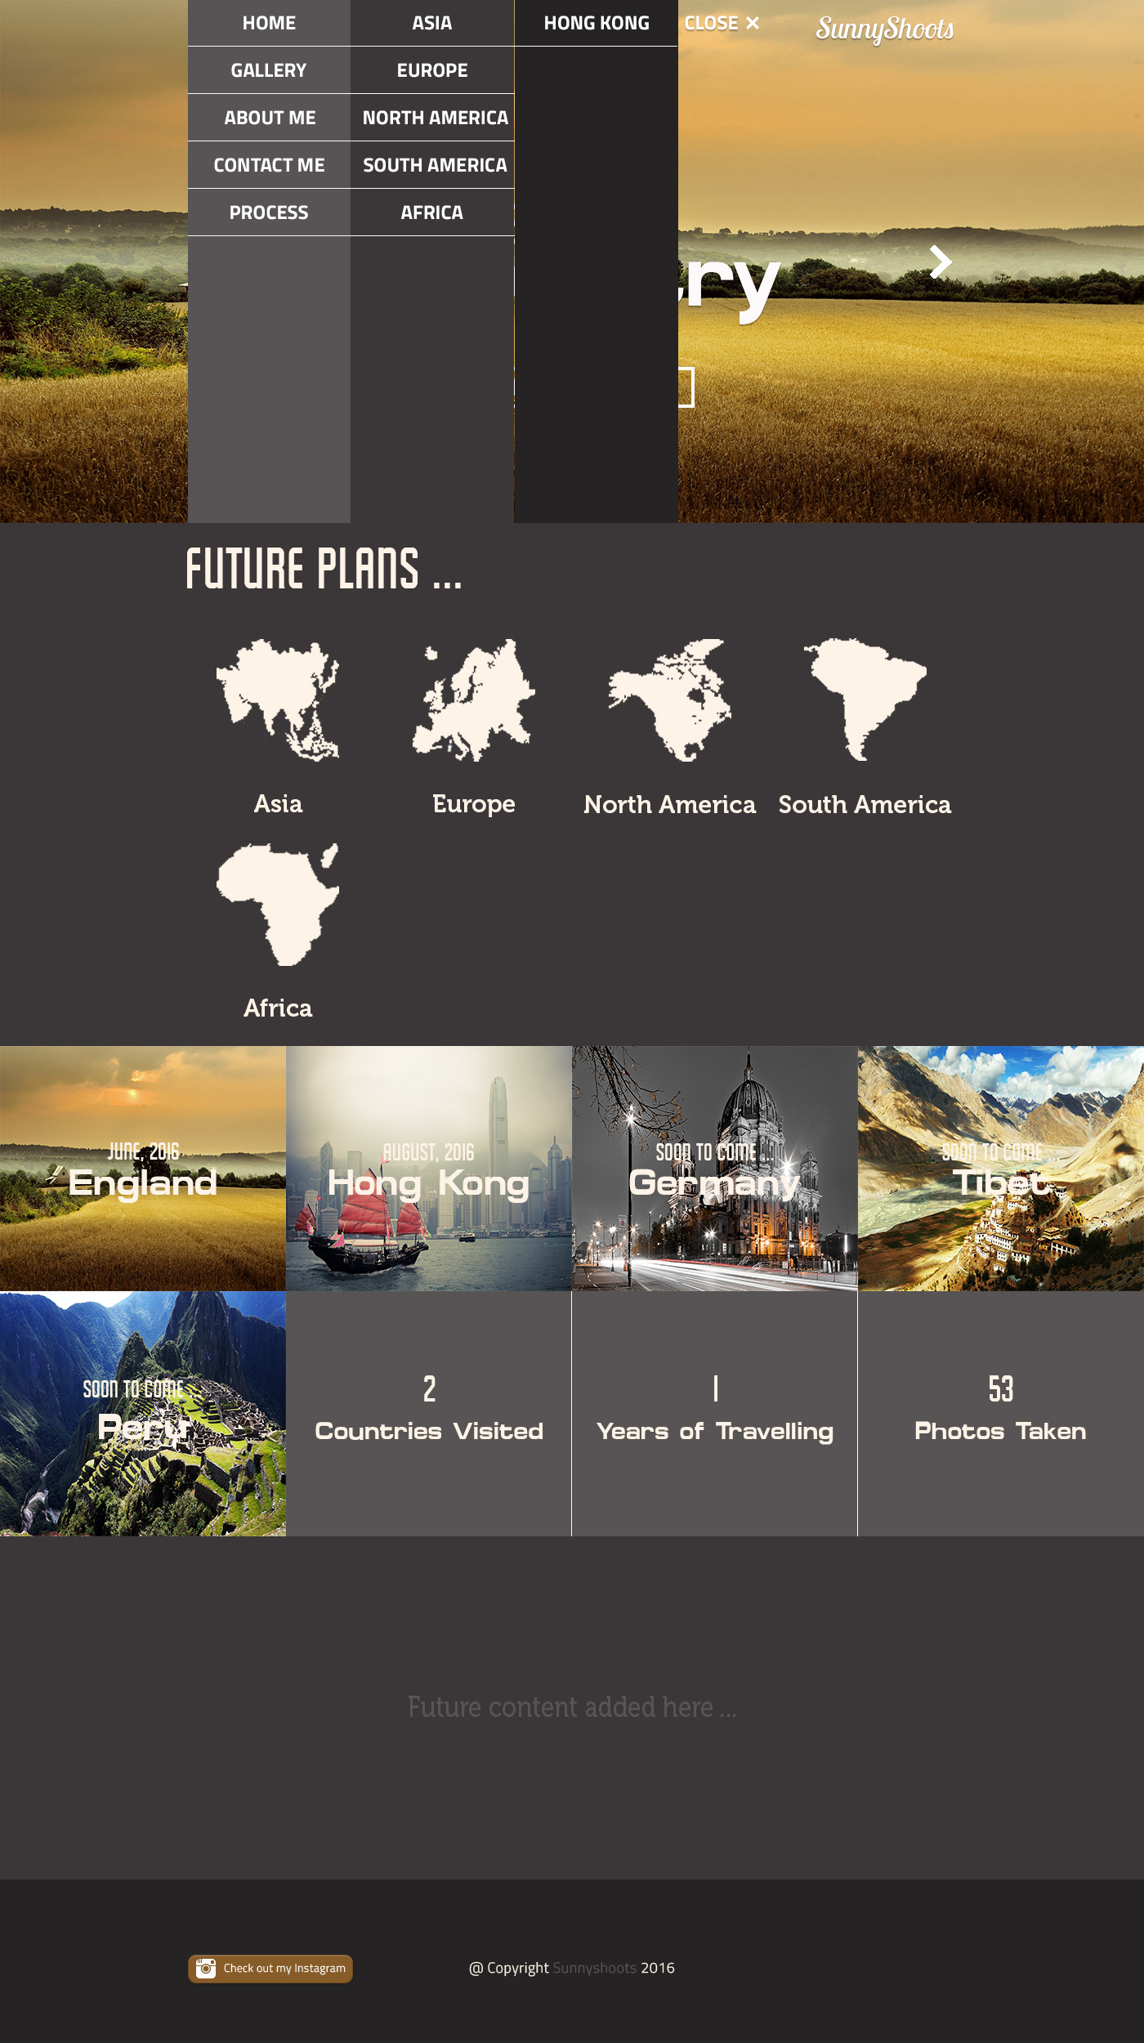

**4.4 Sequence 4 – Gallery Page**

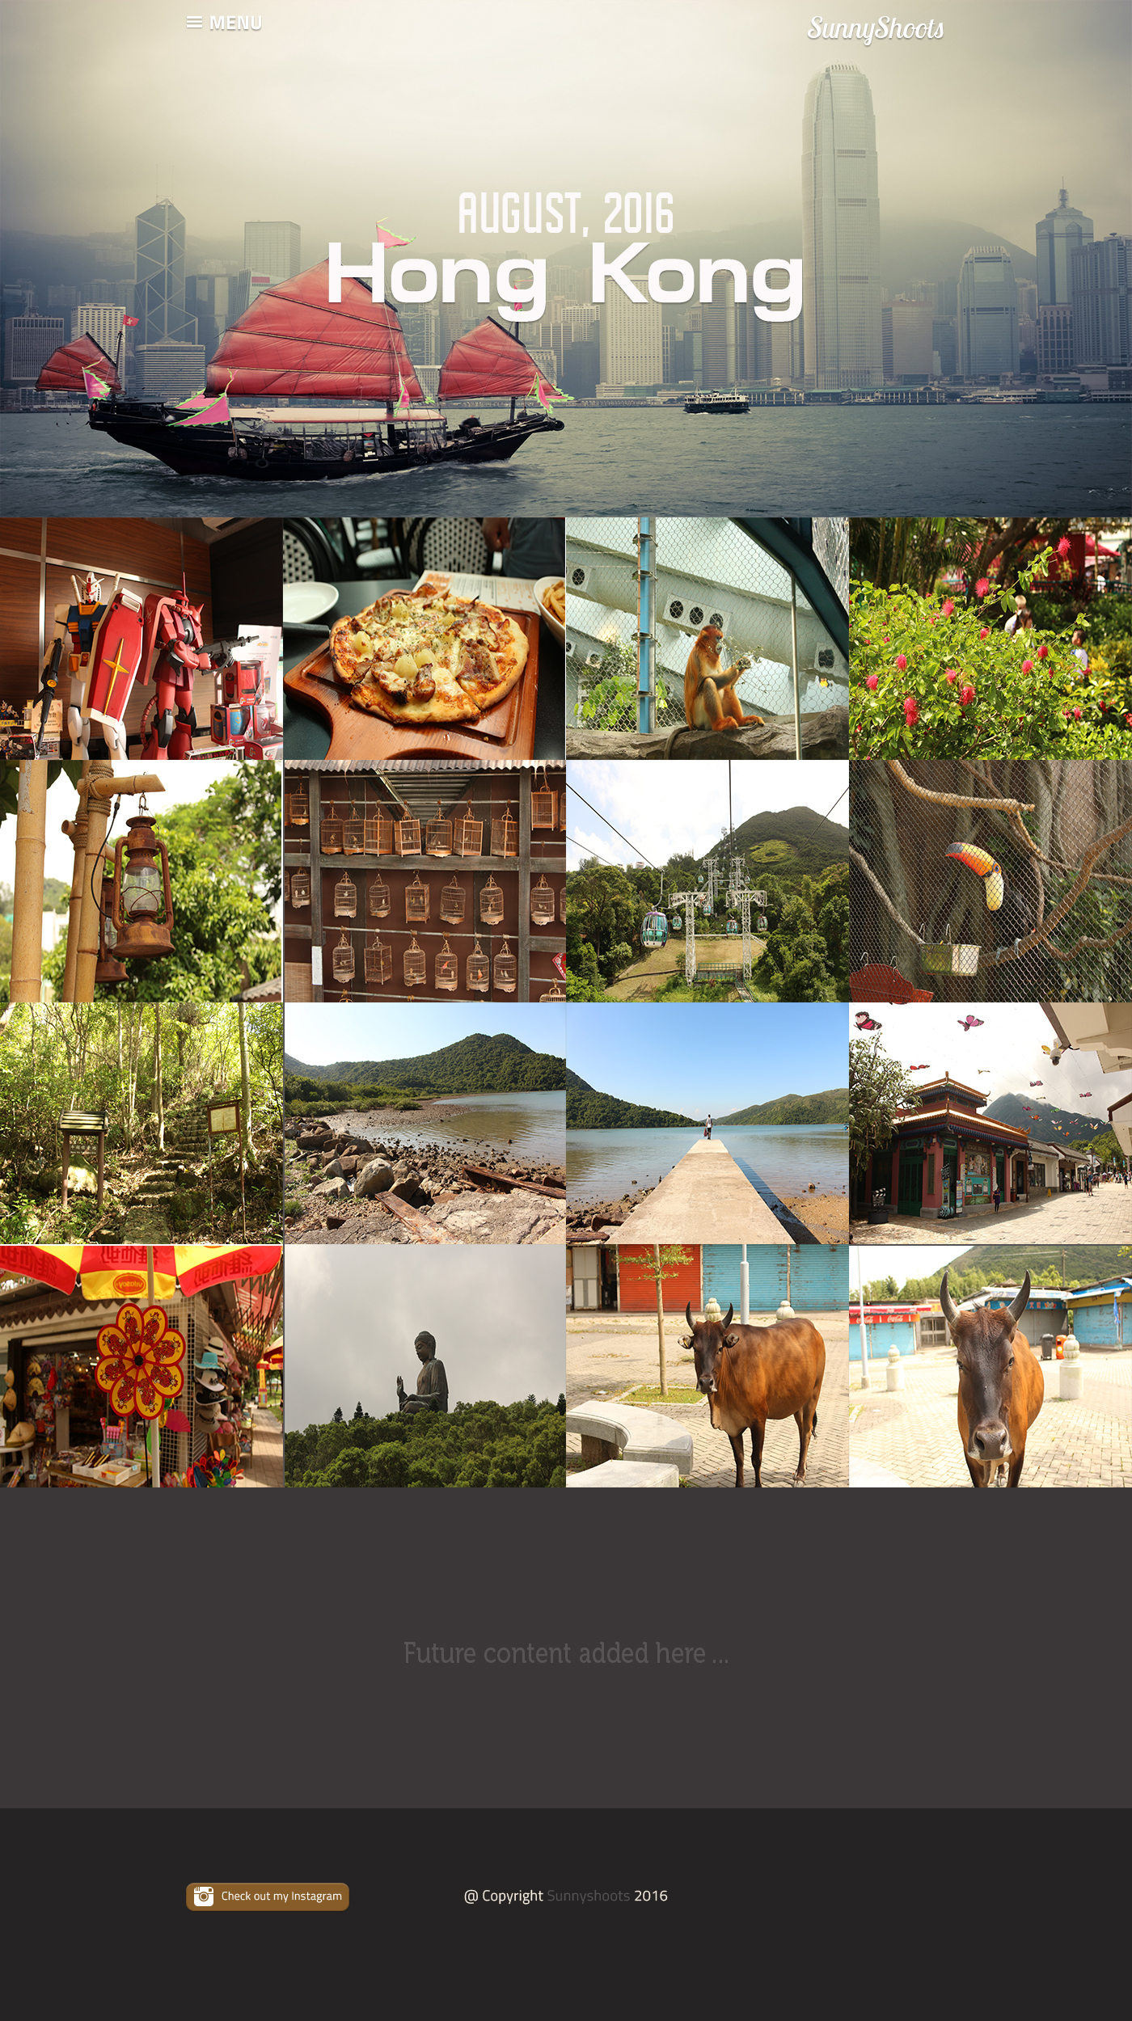

**4.5 Sequence 5 – About Me**

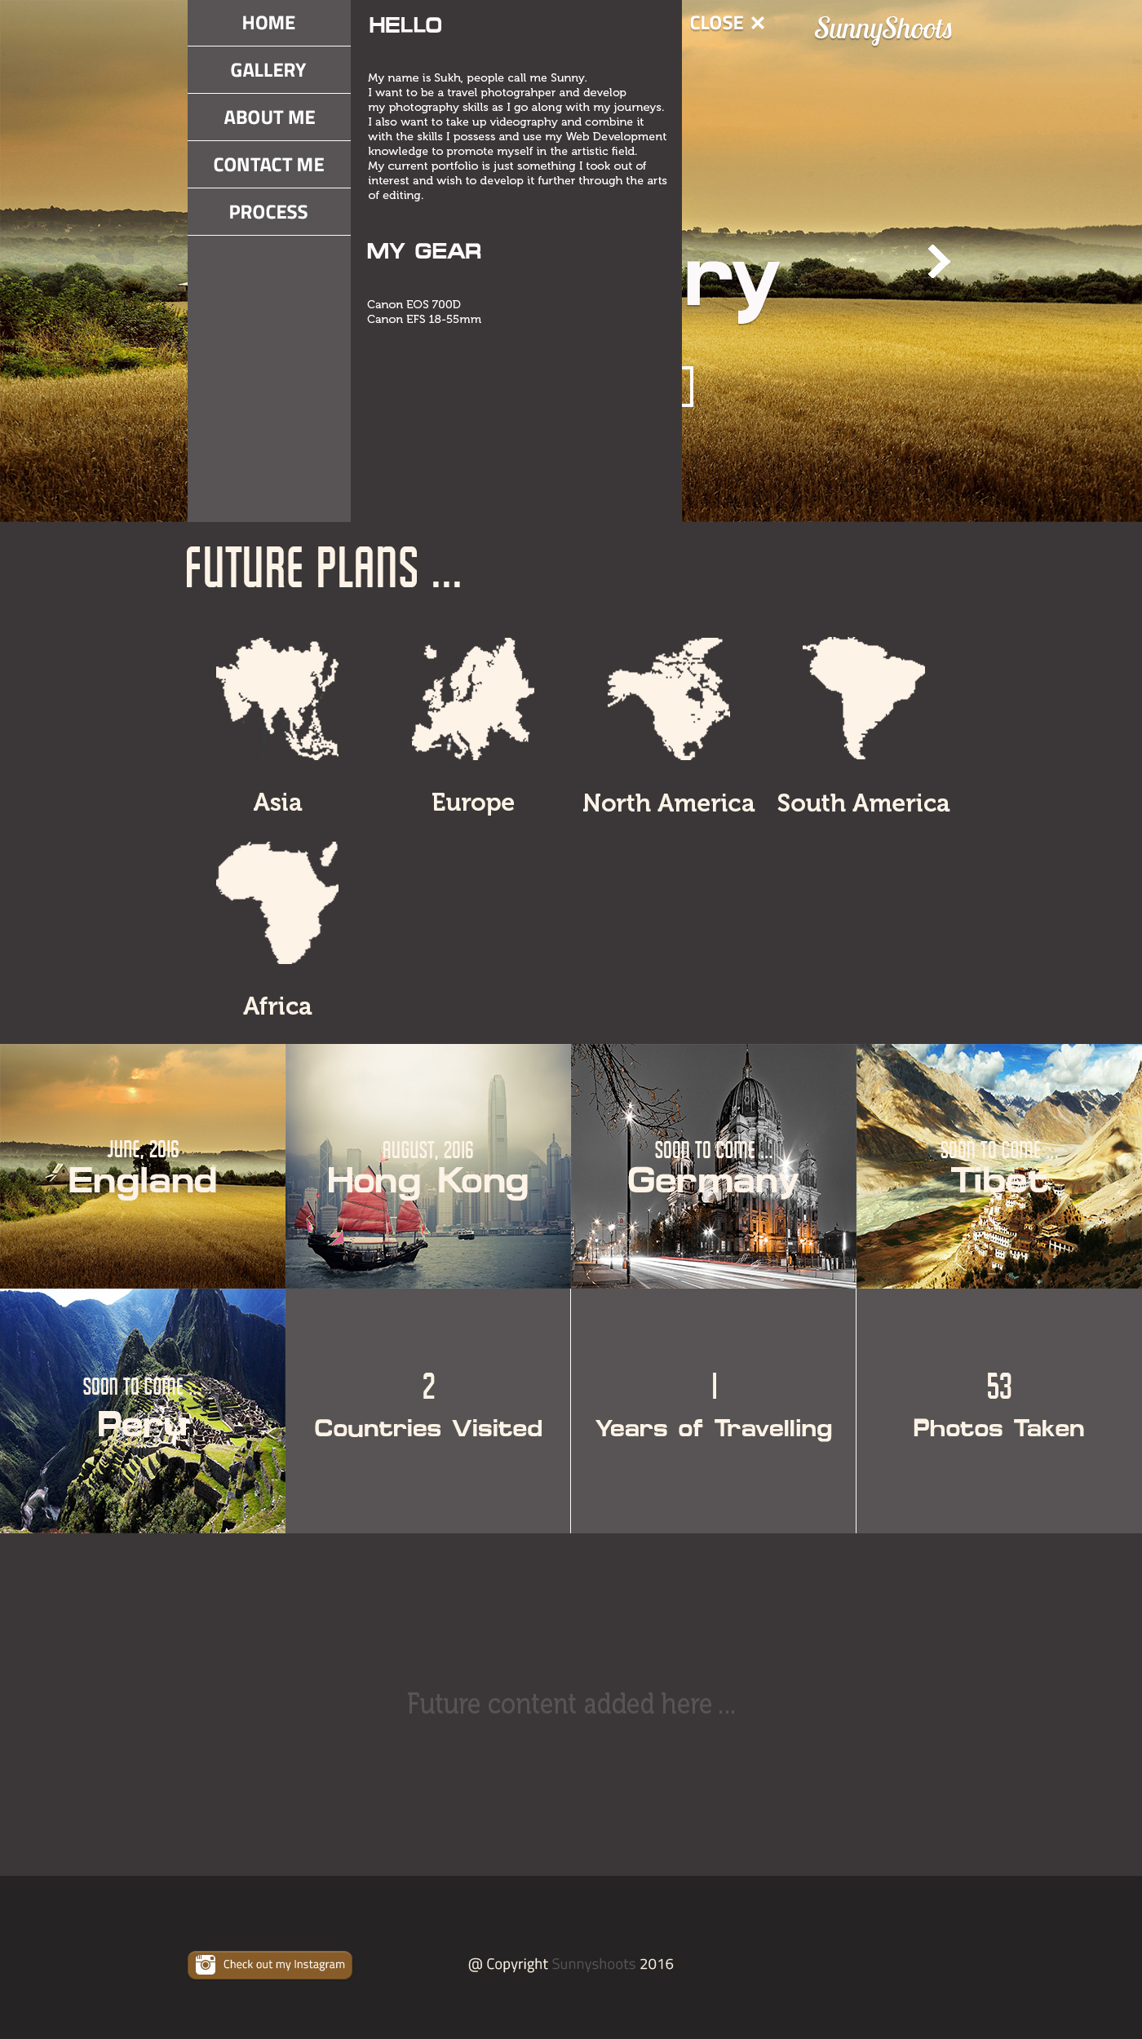

**4.6 Sequence 6 – Contact Me**

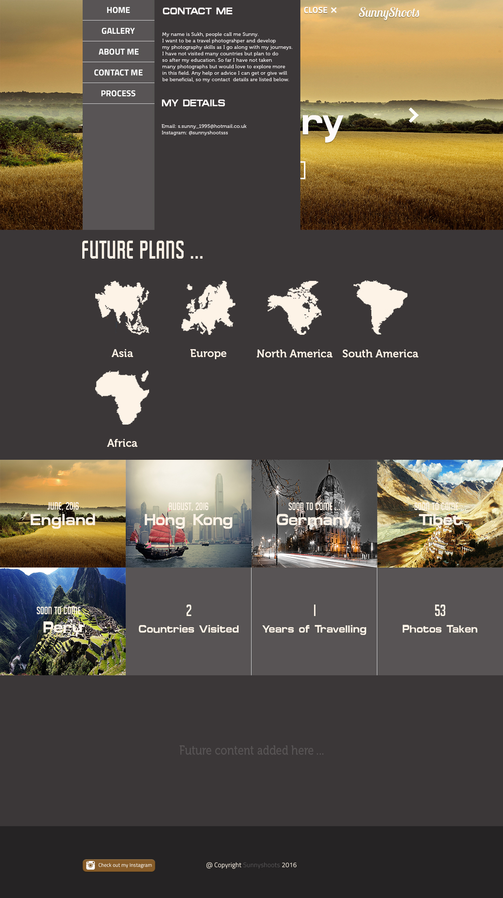

1. **Started working on index.html**

Index.html is the page that is loaded first. There are only 3 pages altogether for this site which consists of the Home page and the 2 Gallery Pages: England Gallery and Hong Kong Gallery.

The structuring of the index.html page was done using Bootstrap for grid layout and Bootstrap is a quick framework utilized for developing the site. However, this was only used for the construction of grids and the rest of the layout representation is done manually.

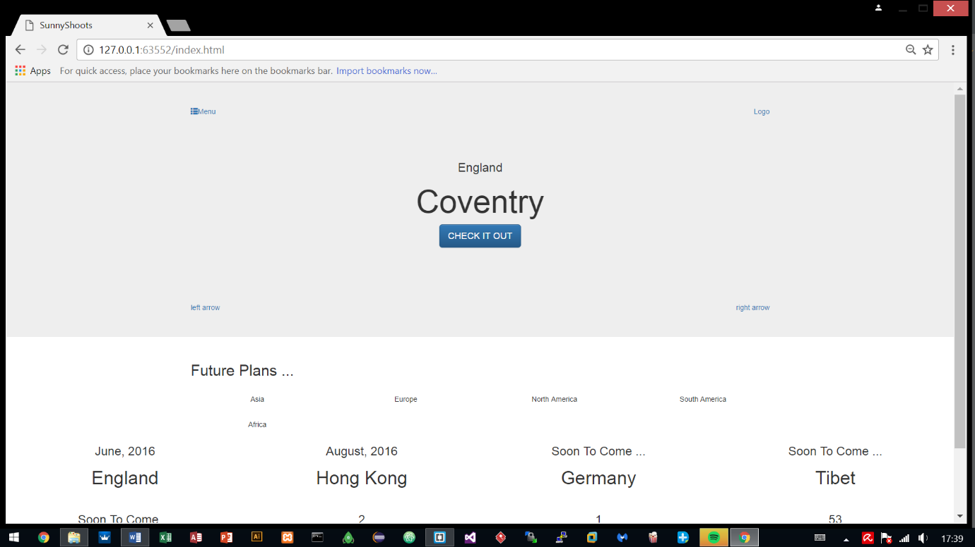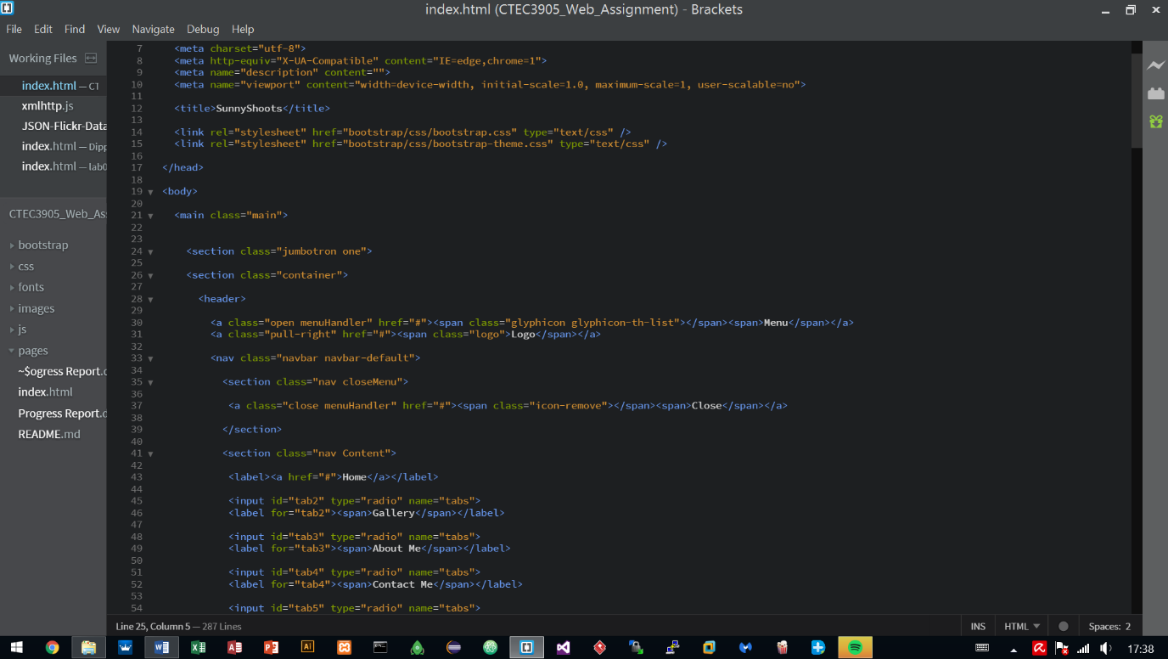The reason for using Bootstrap is because it has been utilised before in other projects and has proven to work well, providing quick results so other areas could be looked at earlier on such as using animations and JavaScript to handle parts of the site.

* 1. **Added two more pages – hongkong.html and england.html**

After working on the index.html, two more pages were added which are the gallery pages, displaying photographs of the places that were visited and the pages are titled according to the countries/cities visited.

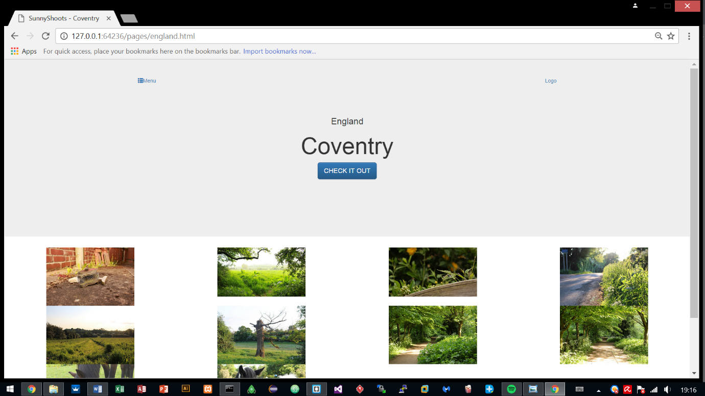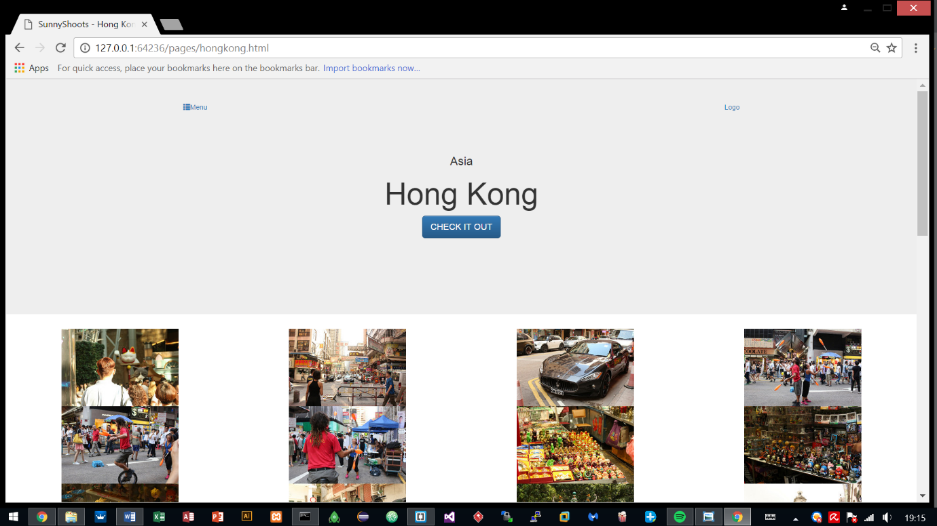The syntax for both pages have a similar layout in contrast with the index.html so most of it was just copied towards these html files and was edited. The two pages share the exact same syntax, only required changing of the class names.

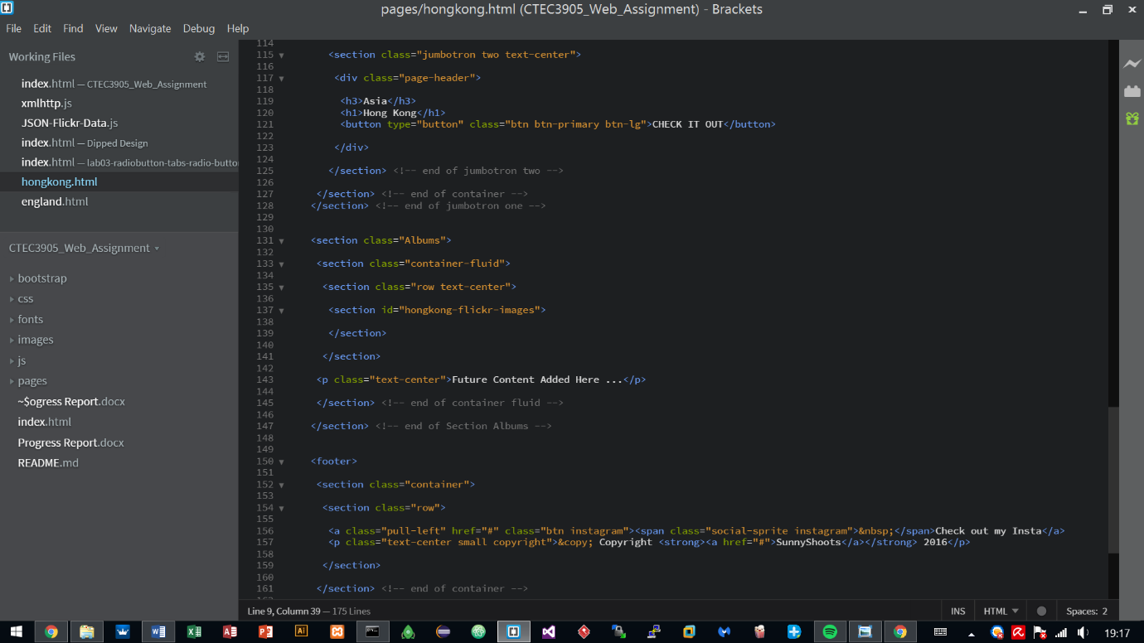

1. **Styling**

Styling started and has been done on the 1st and 2nd sections during the earlier stages of the site, other parts were still in progress.

The fonts and logos were initialised to what the interface designs showed and at that stage it was majorly focused on finishing off the style so other areas such animations and JavaScript, could be looked into.

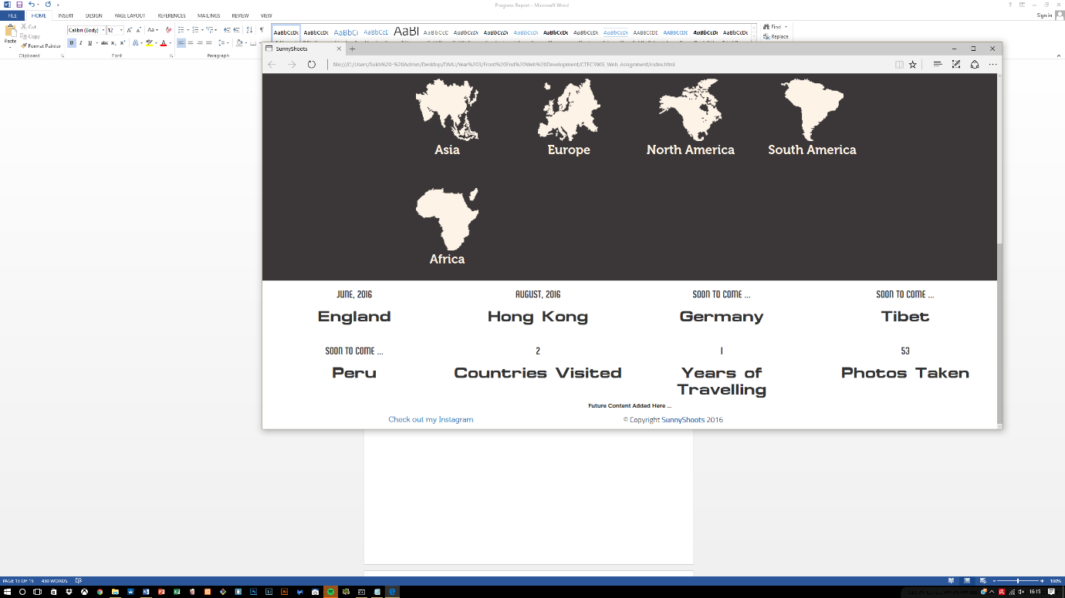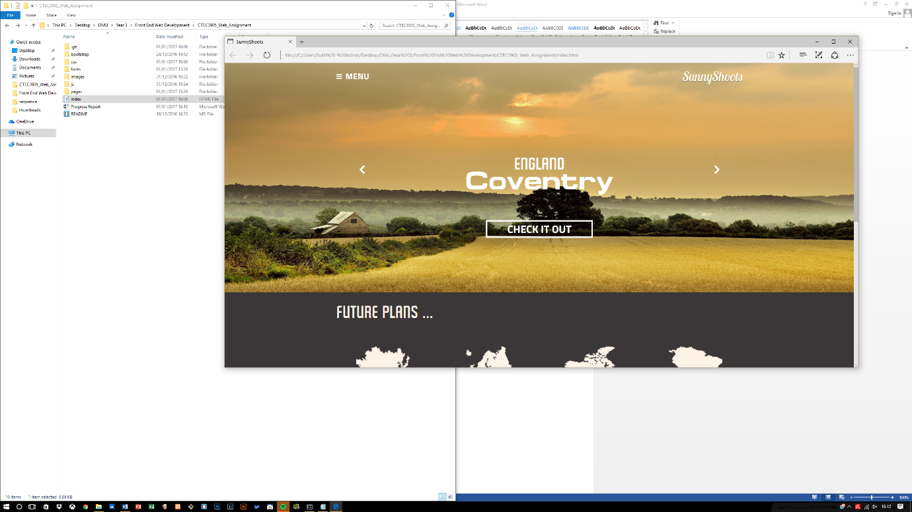

Two CSS stylesheets are being utilized, the rest is what Bootstrap provides by default. All styling has been done manually, Bootstrap, as said previously only provided a means to create grid layouts to quickly dive into other areas.

***Font.css*** sets up the font families that can be utilized within the development of the site and the ***style.css*** works by changing what bootstrap provides to suit to the interface design.

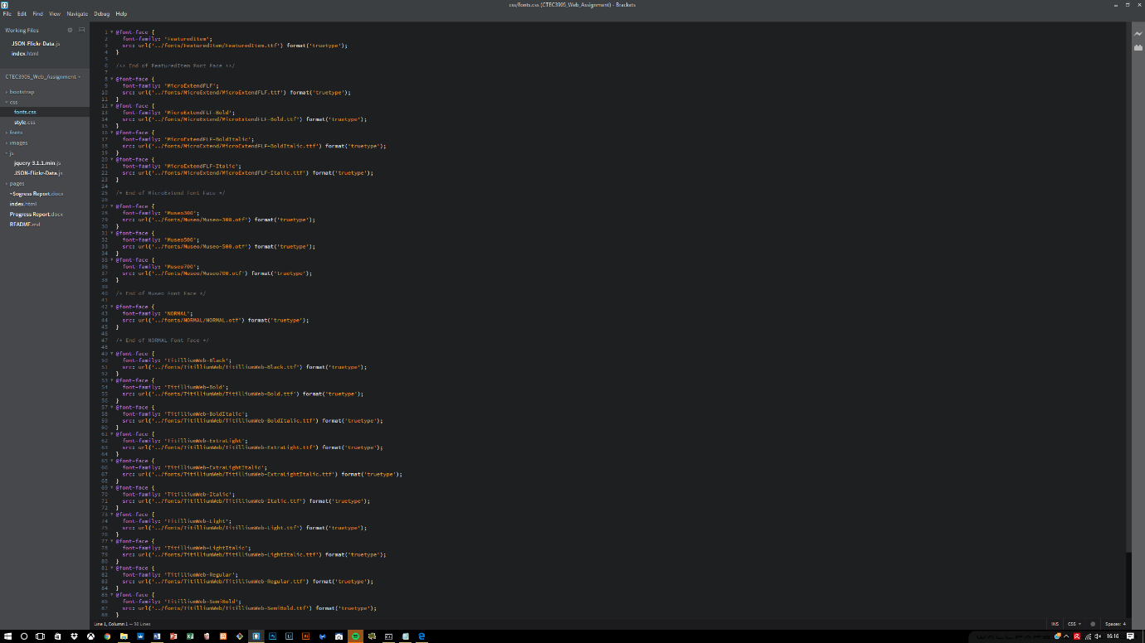

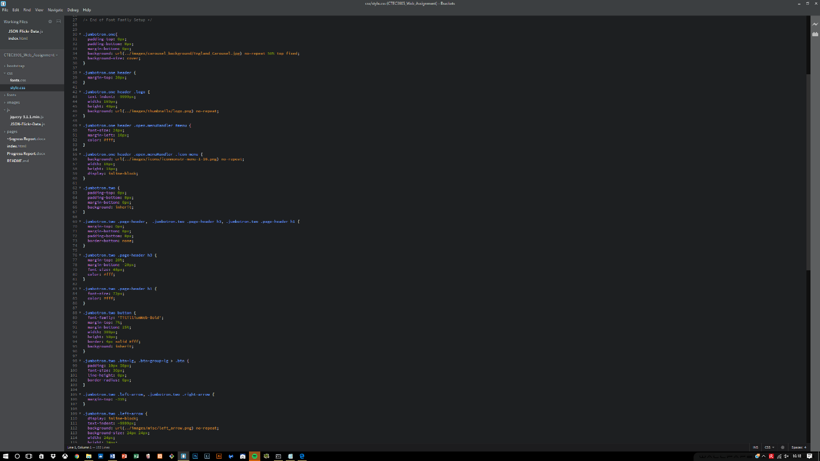

**6.1 Errors encountered within the first section**

During the development, an early realisation was made on the structure of the semantics which was not correct. The menu header was inside a container which held other main containers which should not have been there.

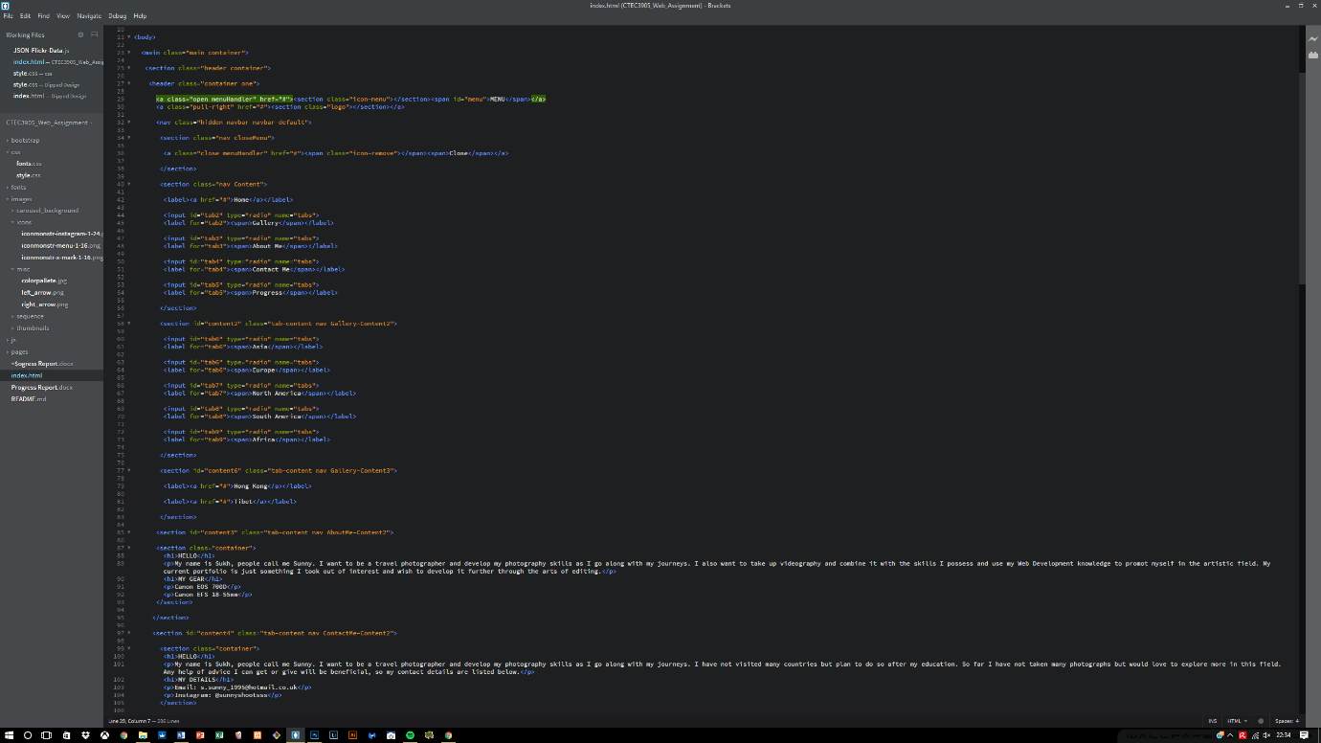Therefore the entire process took a lot of time due to rearranging of the structure and now the structure is working fine, the menu header is fixed and separated from the other content within the container. There is now the main container holding the entire site, and different containers holding relevant content.

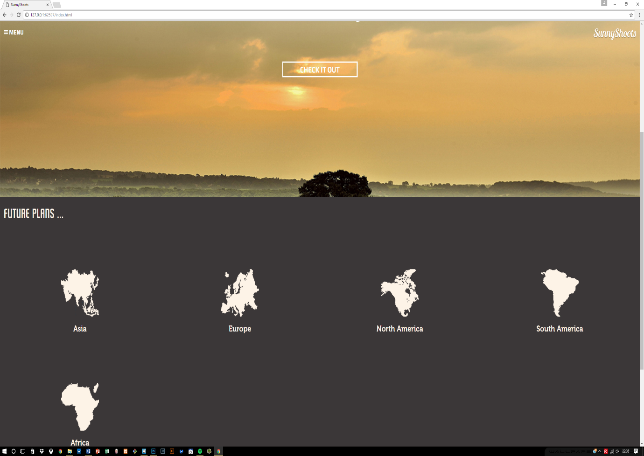

**6.2 Progress made after the errors**

After the first encounter with the errors, it was daunting to correct the mistakes and had to make sure the structure was correct which took up a lot of valuable time but on the contrary, the design aspect finally came to an end. The website was developed according to the interface and all the pages show the correct results.

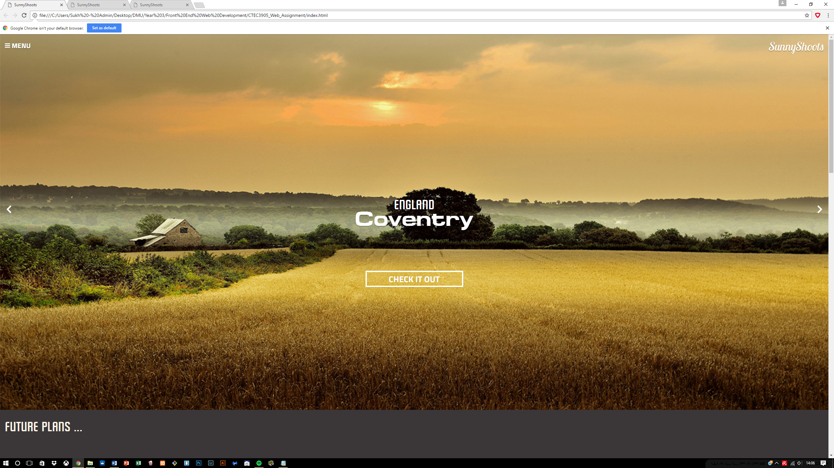

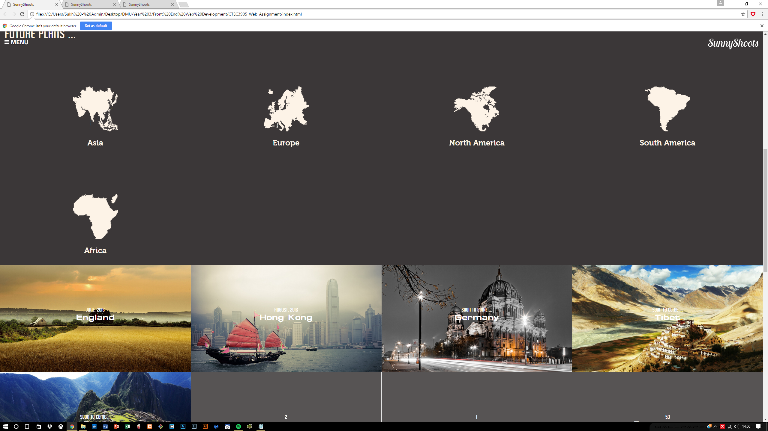

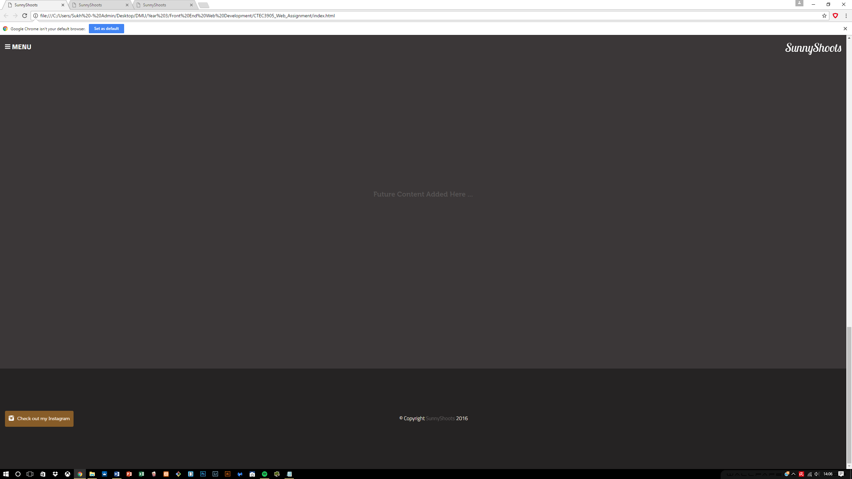

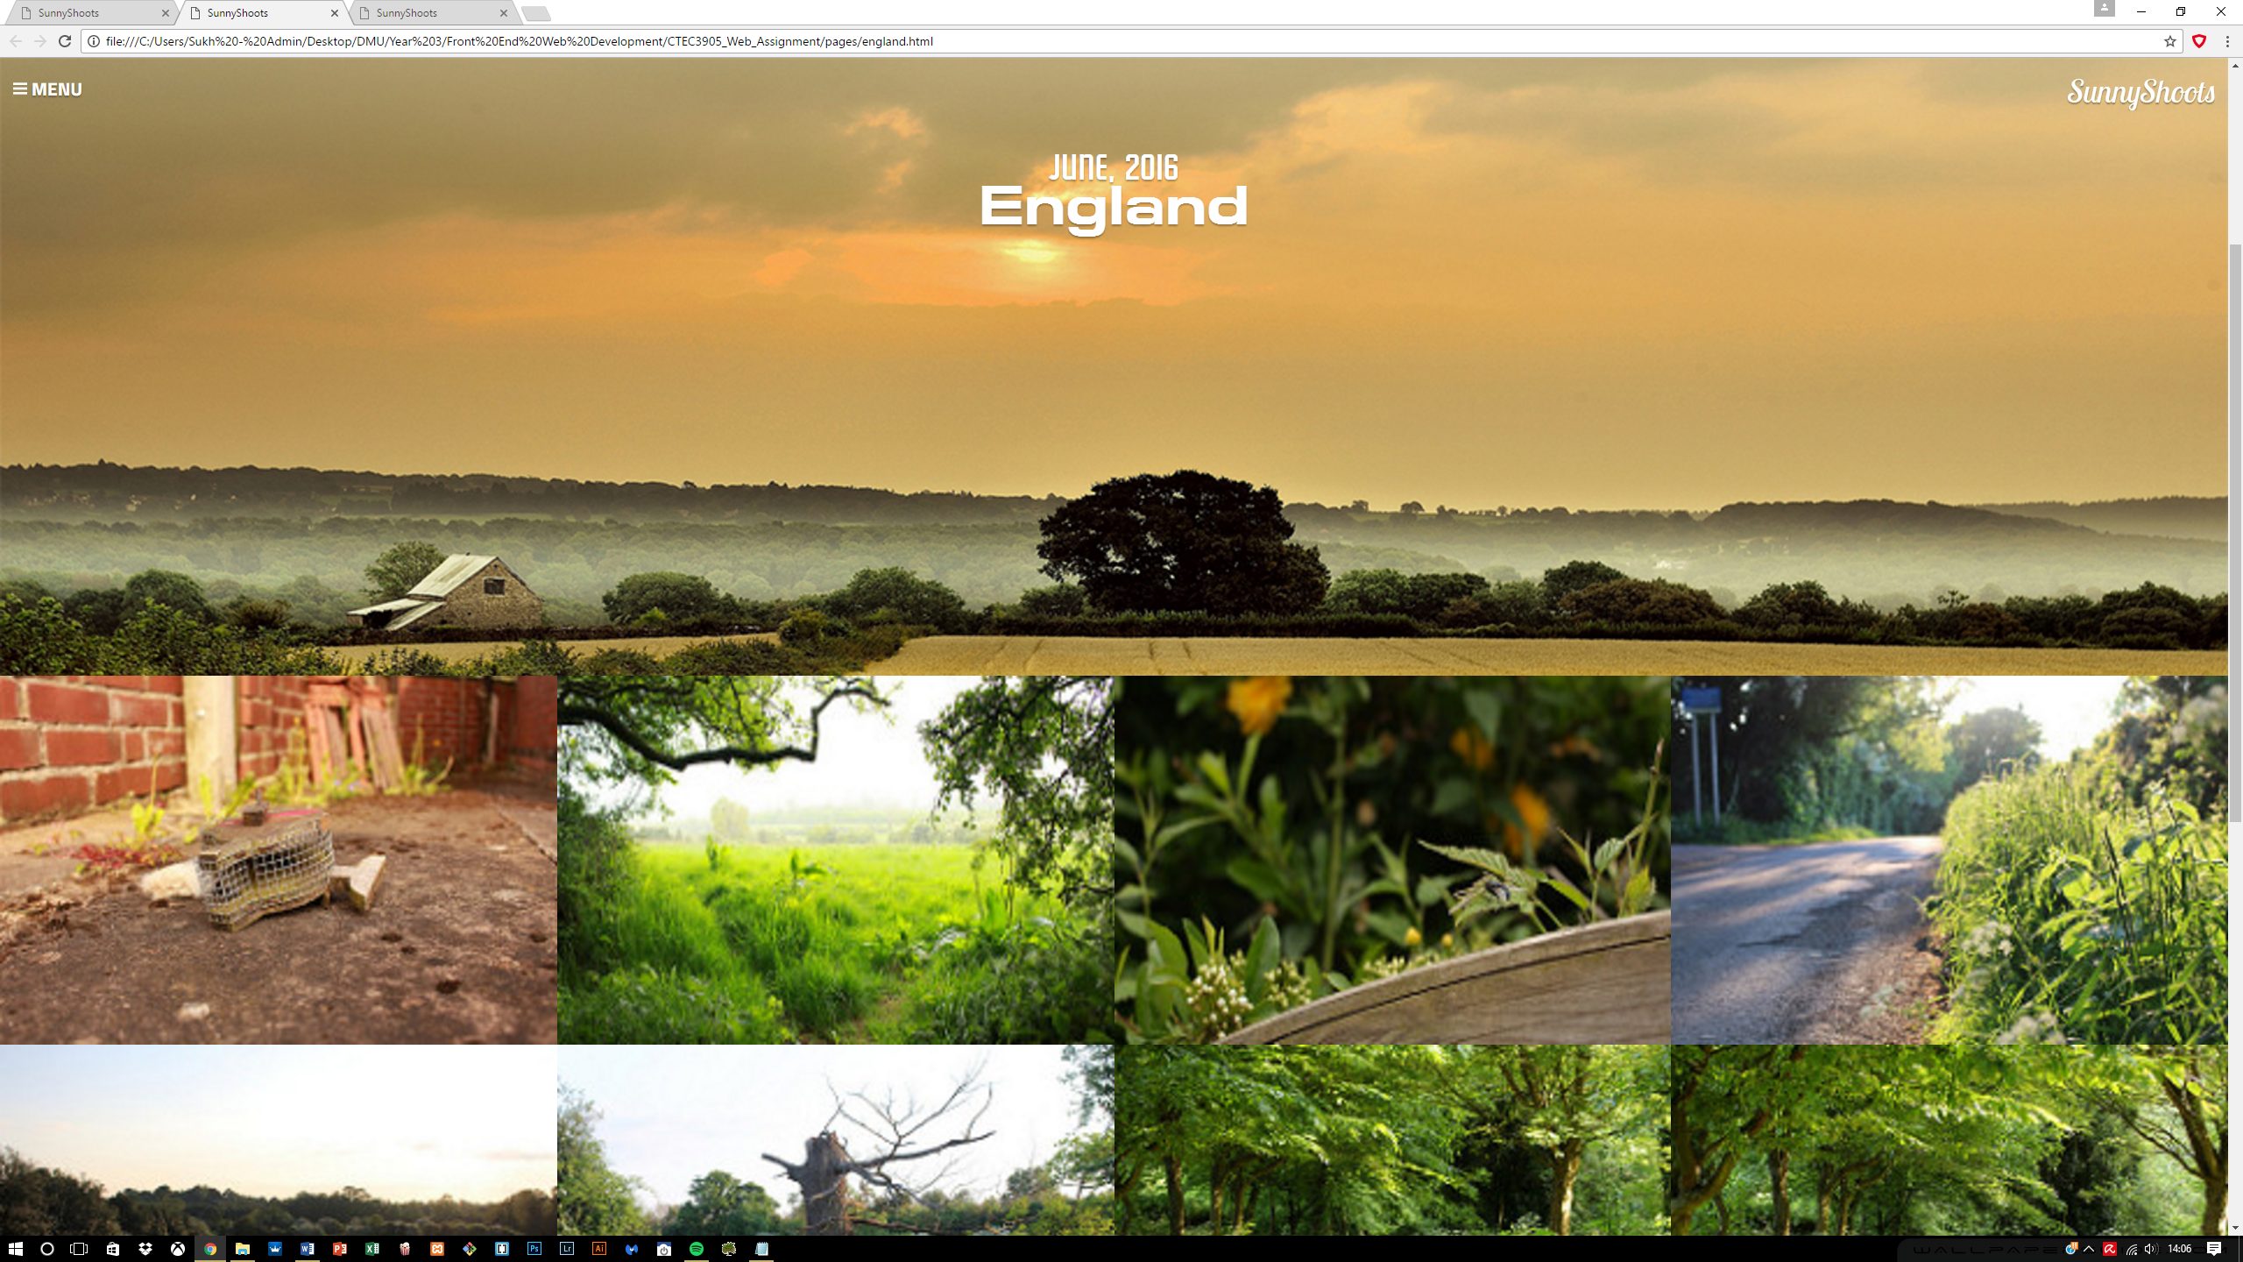

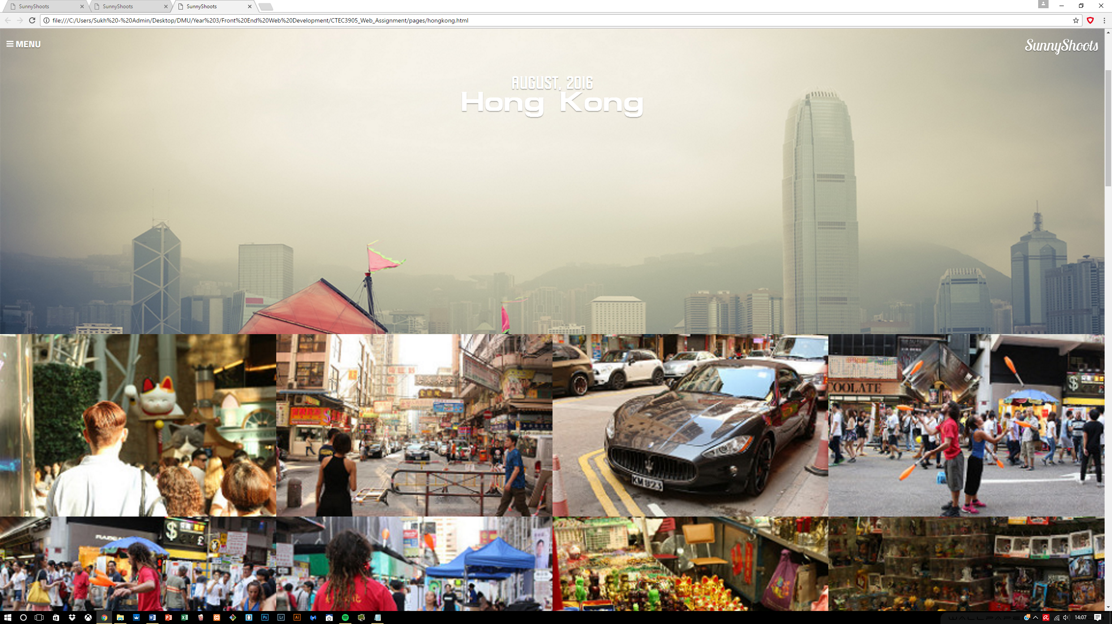

Now the focus was needed on completing the responsive side of this website, so that everything conforms to a standard.

Overall the styling did not come across as hard but it really depended on the HTML structure if any progress was needed to be made and with the help of flexbox I was able to create the images in a wrapped format so they all align on the left as more images are added.

**6.3 Menu creation**

The menu took a while to do due to the complexity involved which required developing it in an entirely new way using radio buttons. It required inputs and labels learnt from one of the University web development lab sessions and in that it suggests using radio buttons as the navigation panel. These radio buttons are hidden and controlled by the labels which act as buttons and in return we get what’s shown below.

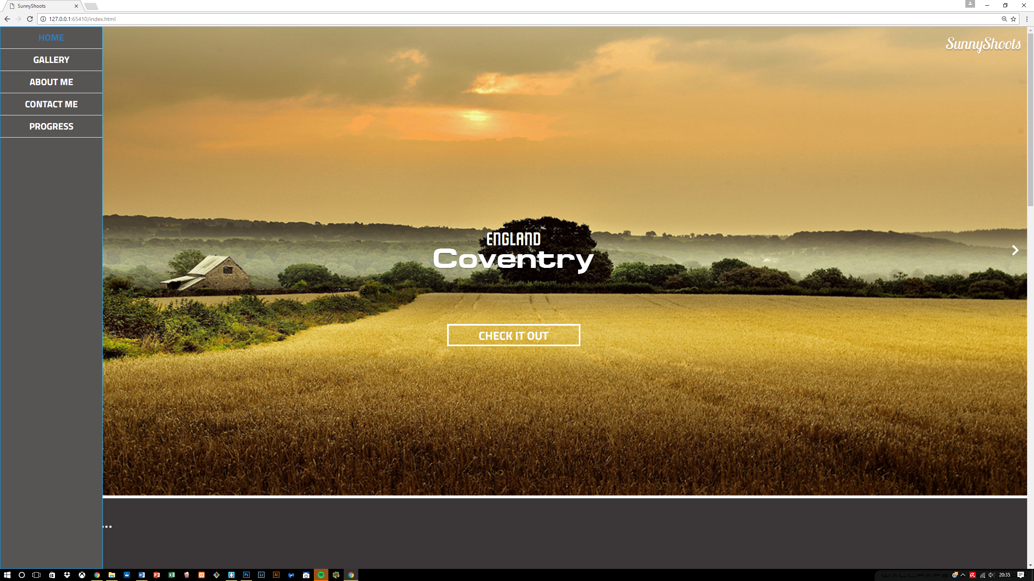

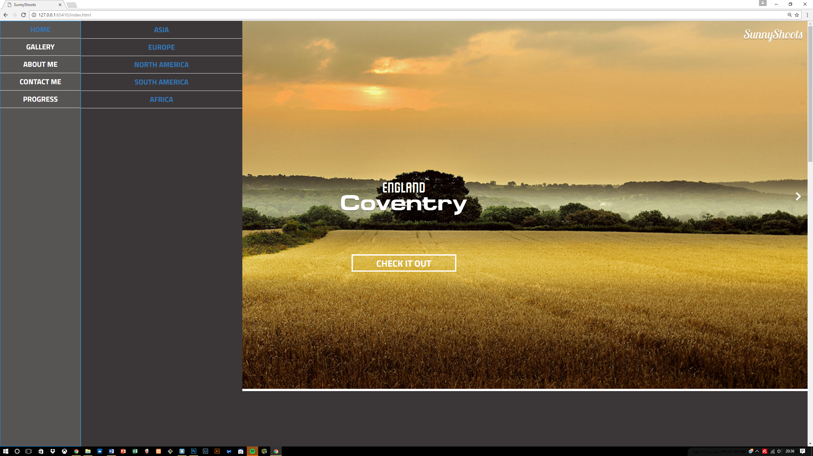

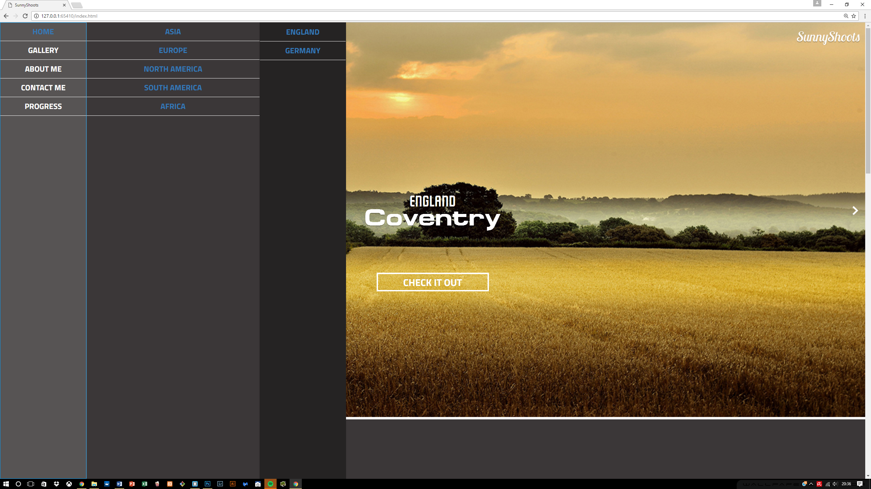

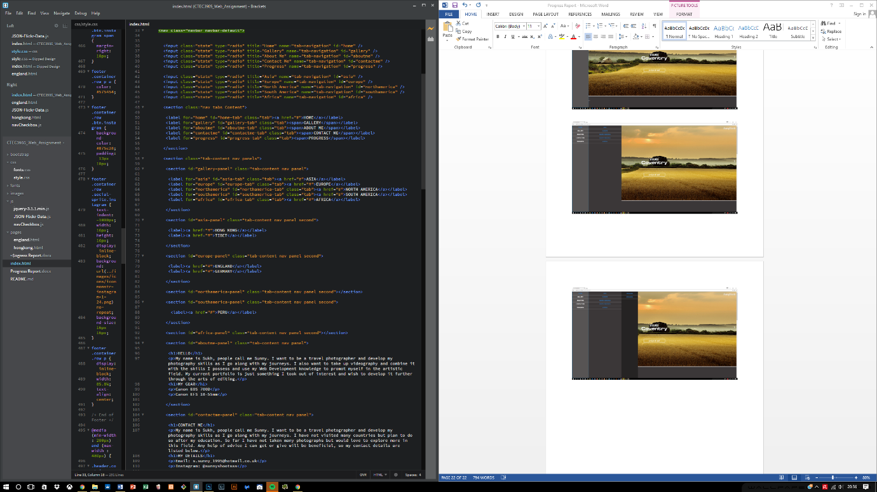

**6.4 Responsive side of the site**

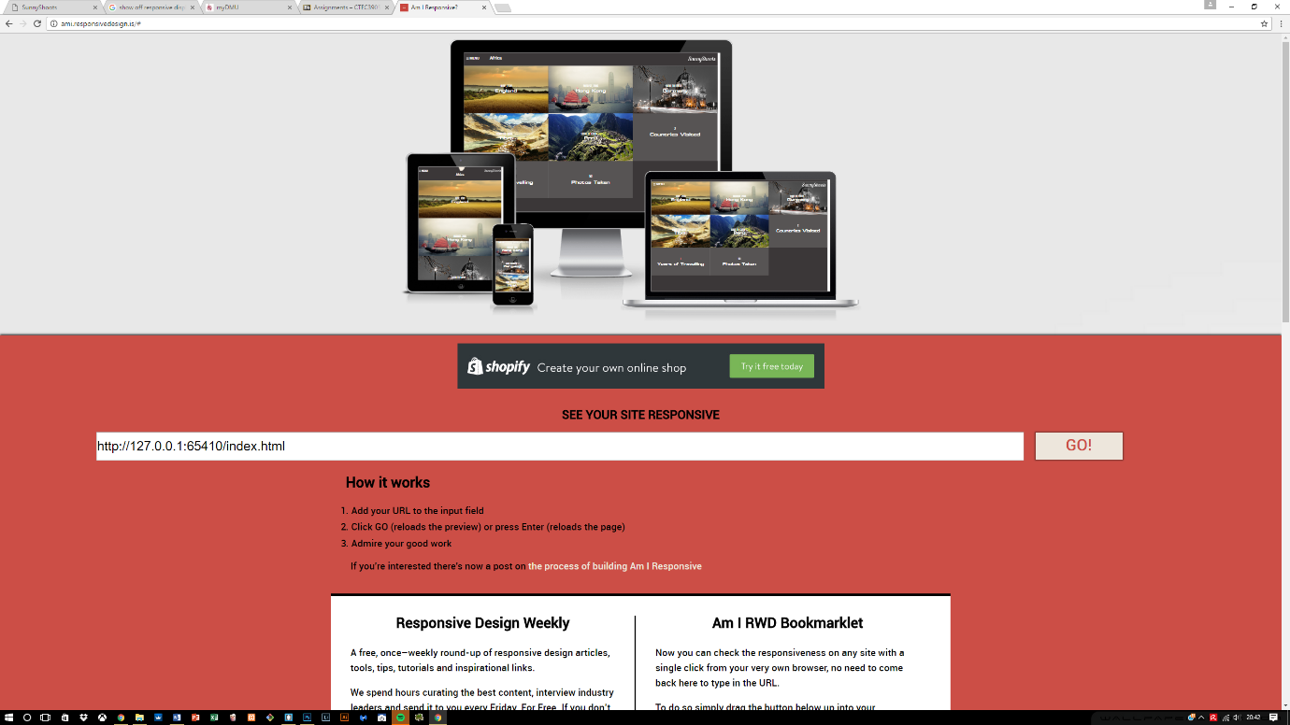After the menu creation, I started working on the responsive aspect of the website which required 4 breakpoints altogether, each of which ranges from the small to the largest device and works perfectly well.

**6.5 Info content moved from Albums content**

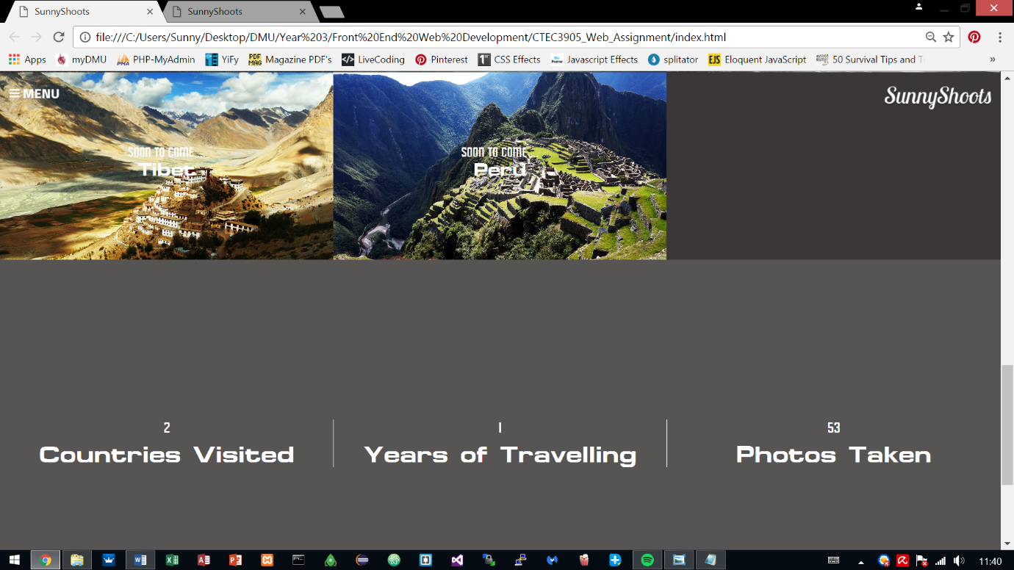The previous information from the Albums content has been moved into its own section which complies with one of the rules in PARC which is contrast and now looks much better when it is separated.

**6.7 Navigation Bar responsive**

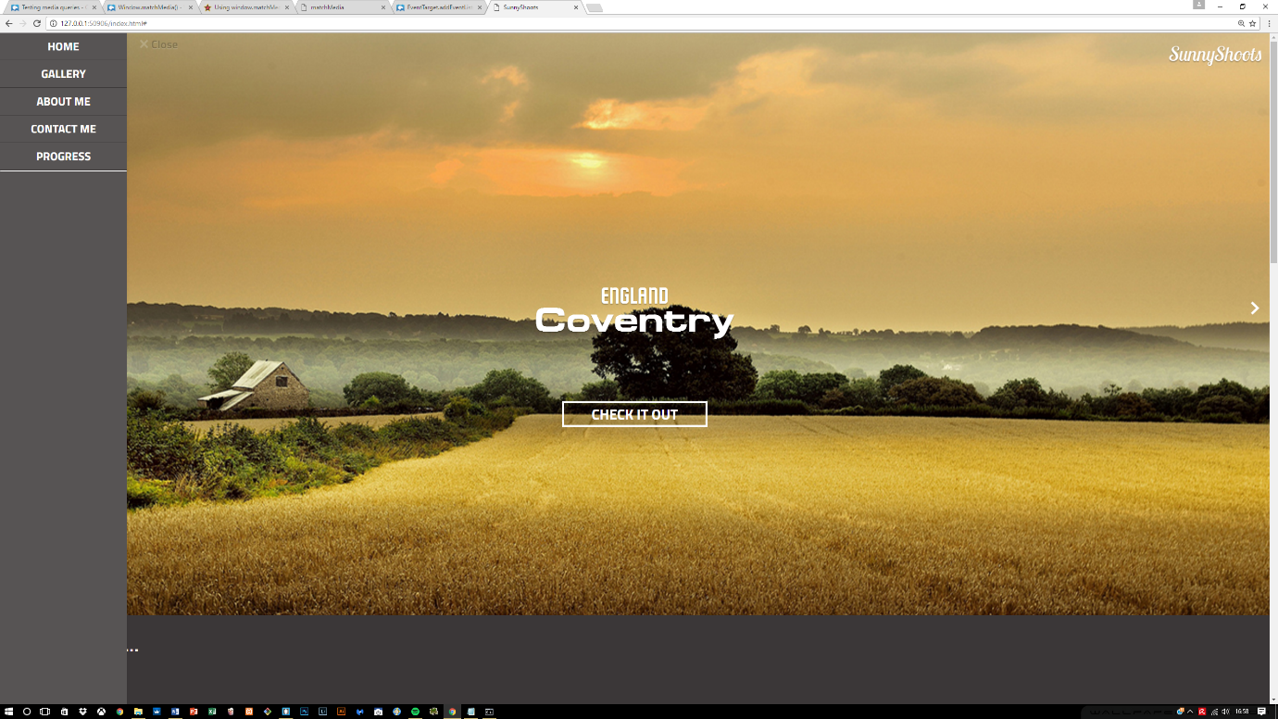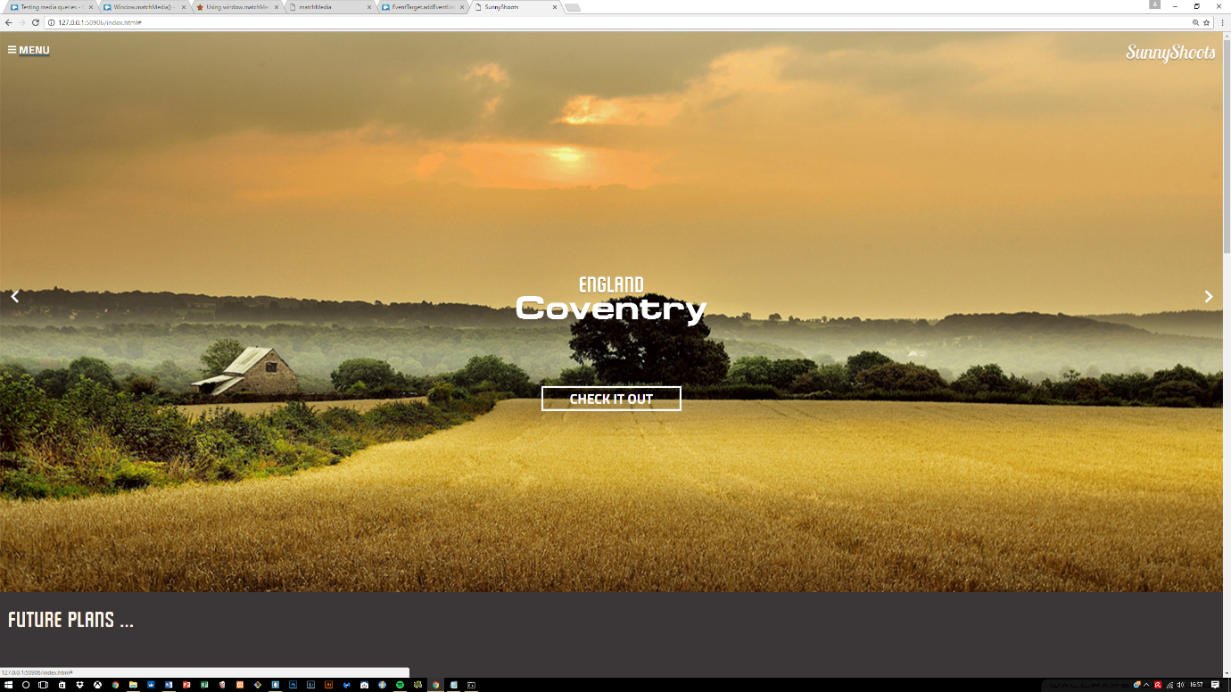Previous navigation bar had to be hidden using the CSS declared for Bootstrap, known as “hidden”. With this the navigation bar was hidden but now within the new changes, using the help of JavaScript it allows the navigation bar to appear and be closed using the Menu and Close buttons.

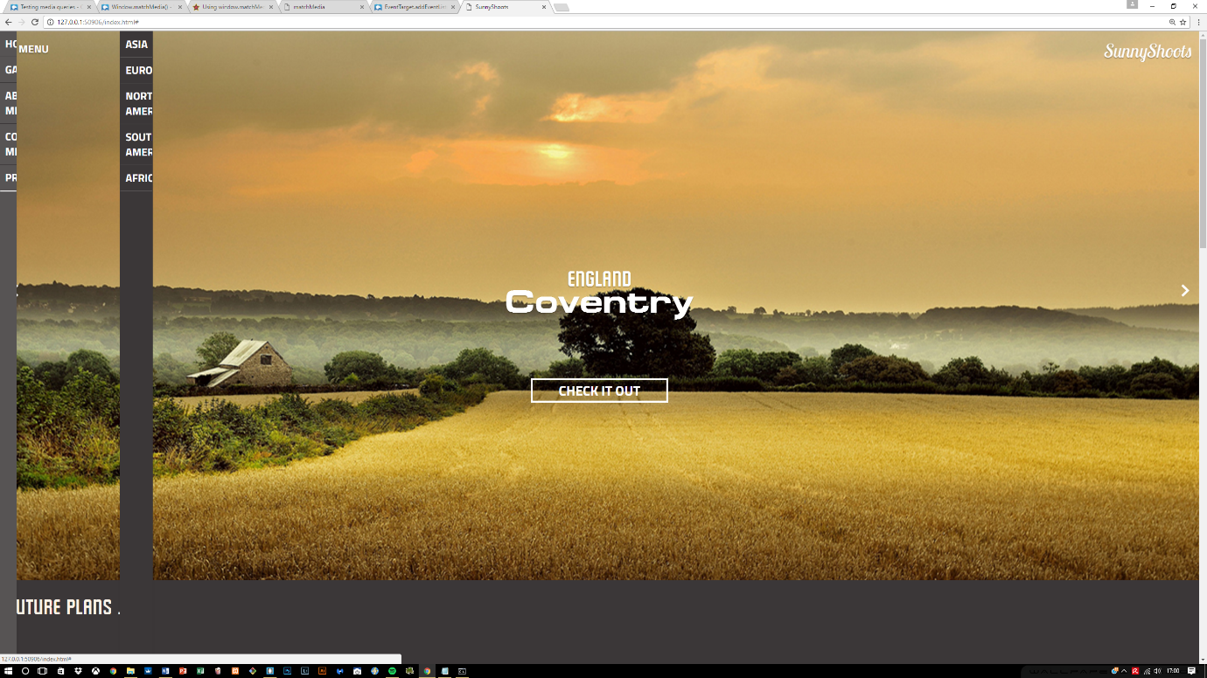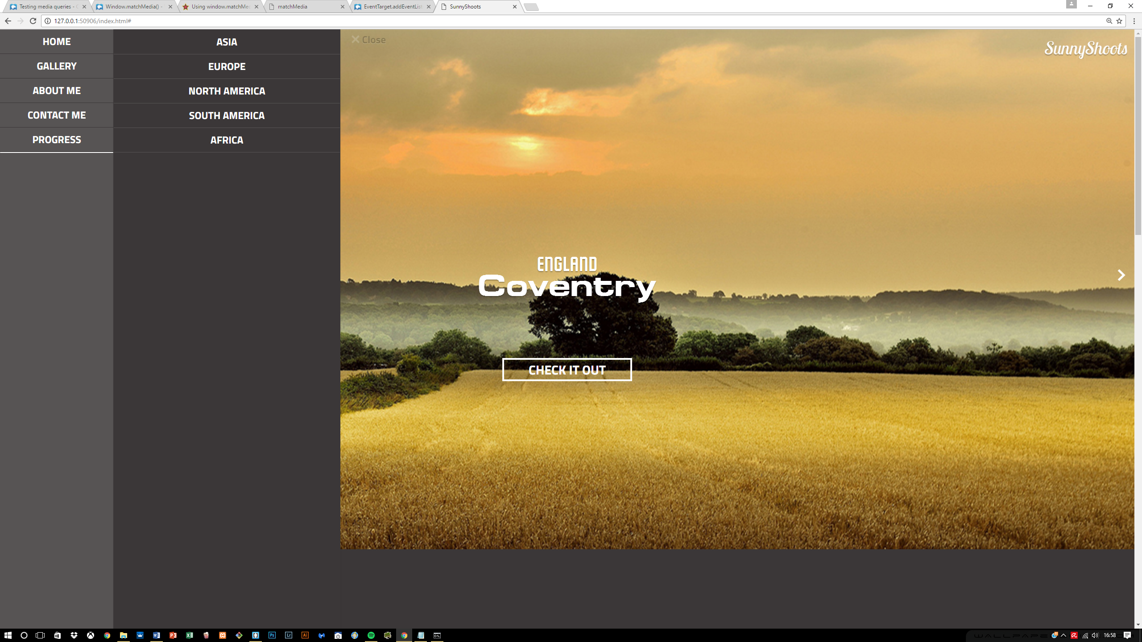

When the close button is clicked, the width is removed within JavaScript for the navigation bar and the transition that is set at 0.5s allows this transitioning to occur creating a nice effect.

The entire navigation bar is done using radio buttons and labels which have been designed within CSS to hide any unwanted properties and allowing thus to maintain the elegancy of the navigation bar. This approach is utilized for testing whether menu can still perform the same way as using anchor tags or unordered lists. The problem with this approach I find is that, it takes a long time to build a menu bar with this approach and a lot of time and configuration that can be easily done with using other tags, is easier compare to this structure.

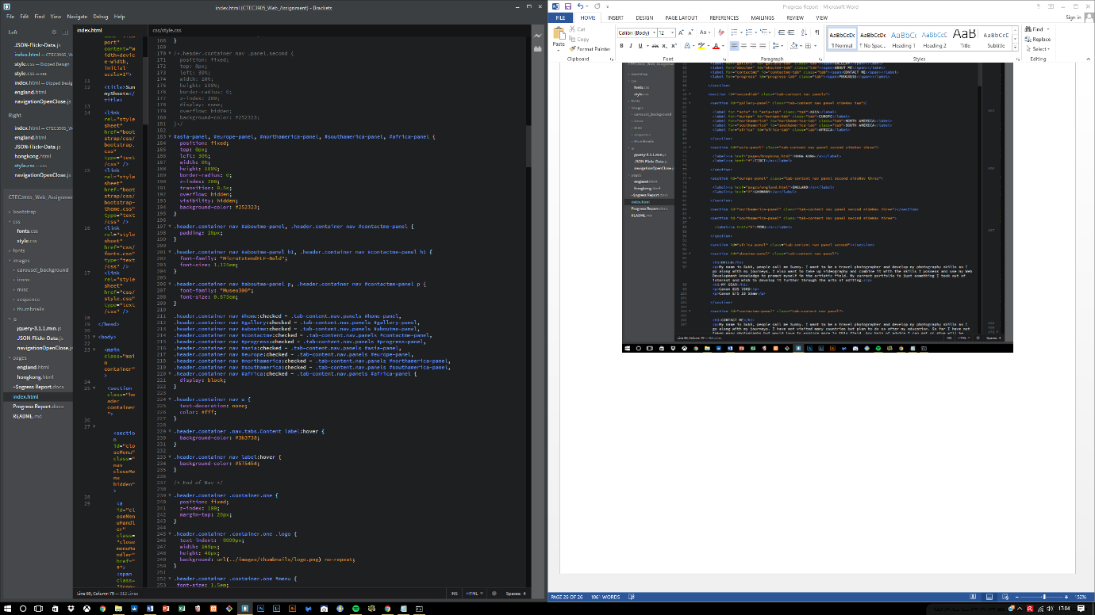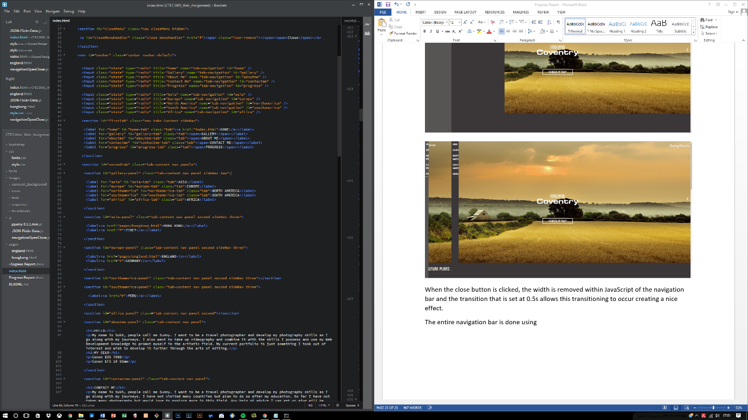The code for this is shown below:

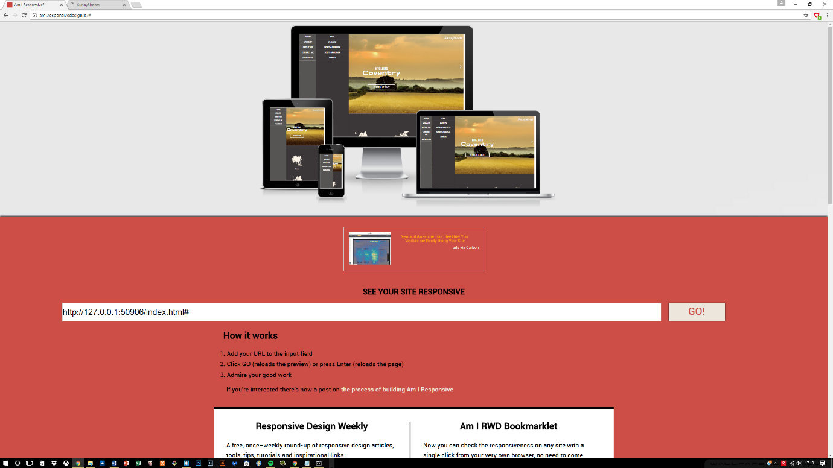At first it seemed impossible to be able to create an interactive menu using labels and radio buttons because of the configuration that needs to go in to it but with the help of JavaScript, it was easy to maintain the responsive aspect of the menu. JavaScript also provides ***window.matchMedia()*** function and with this it was easier to listen for changes within the screen size and helped adopting to the screen sizes.

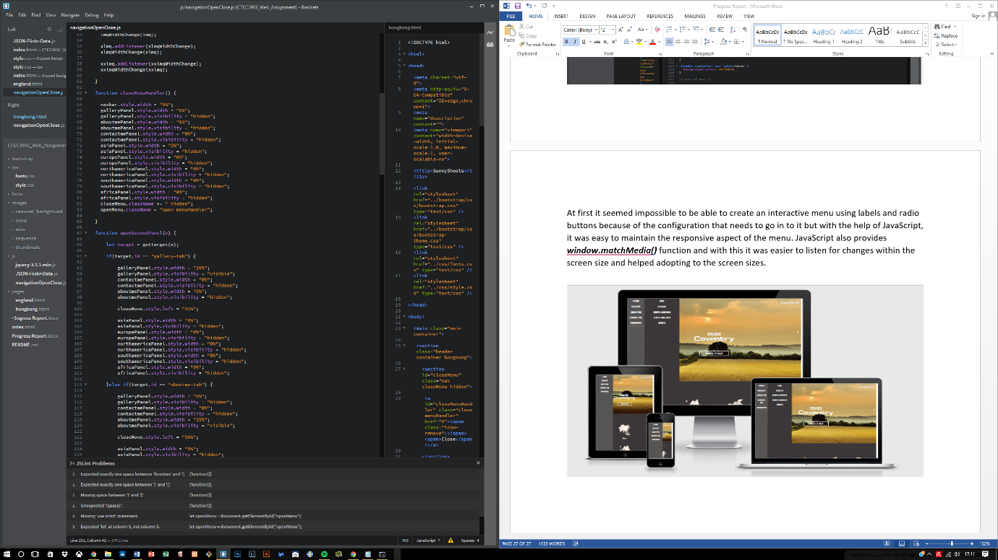

**6.8 Navigation bar finished**

Previous navigation bar dealt with many changes and they included mostly features created in JavaScript. The navigation bar required CSS to hide and show the bar and it did not adjust to different screen sizes, however the new changes and the final changes that have been done to it are of the following:

* No use of “hidden” within the CSS to hide the navigation bar
* Uses menu and close buttons to open and close navigation bar
* With the help of **window.matchMedia(),** it now performs much better when resized, using 5 different media query listeners ranging from the smallest to largest size.
* 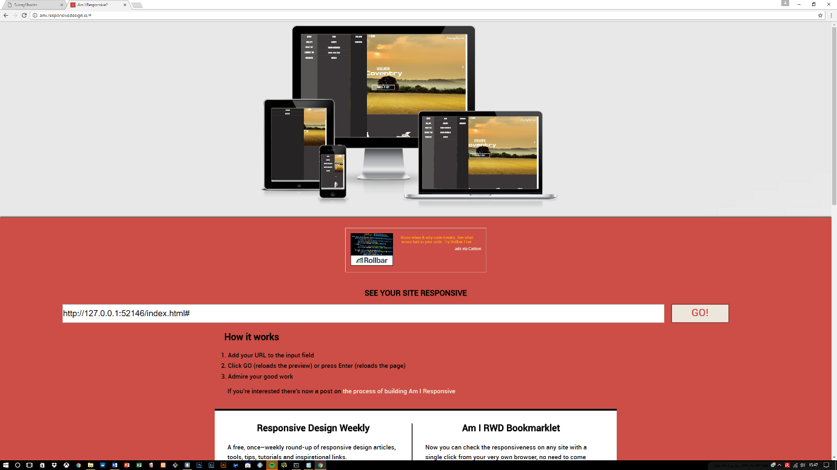Each screen size has a different style of navigation, some are 3 tabbed on larger screens and on smaller screens its 1 tab.

**6.9 Image hover effect**

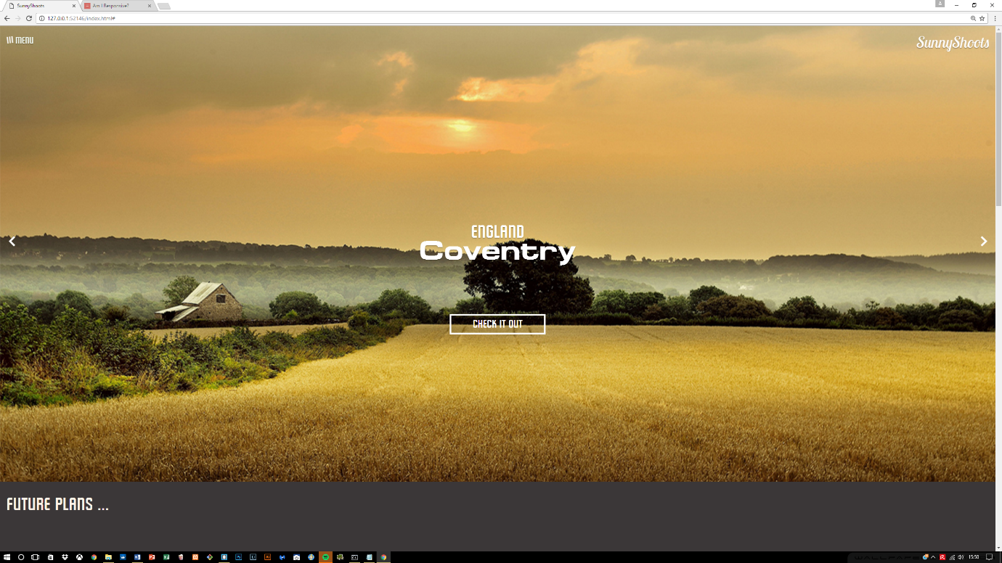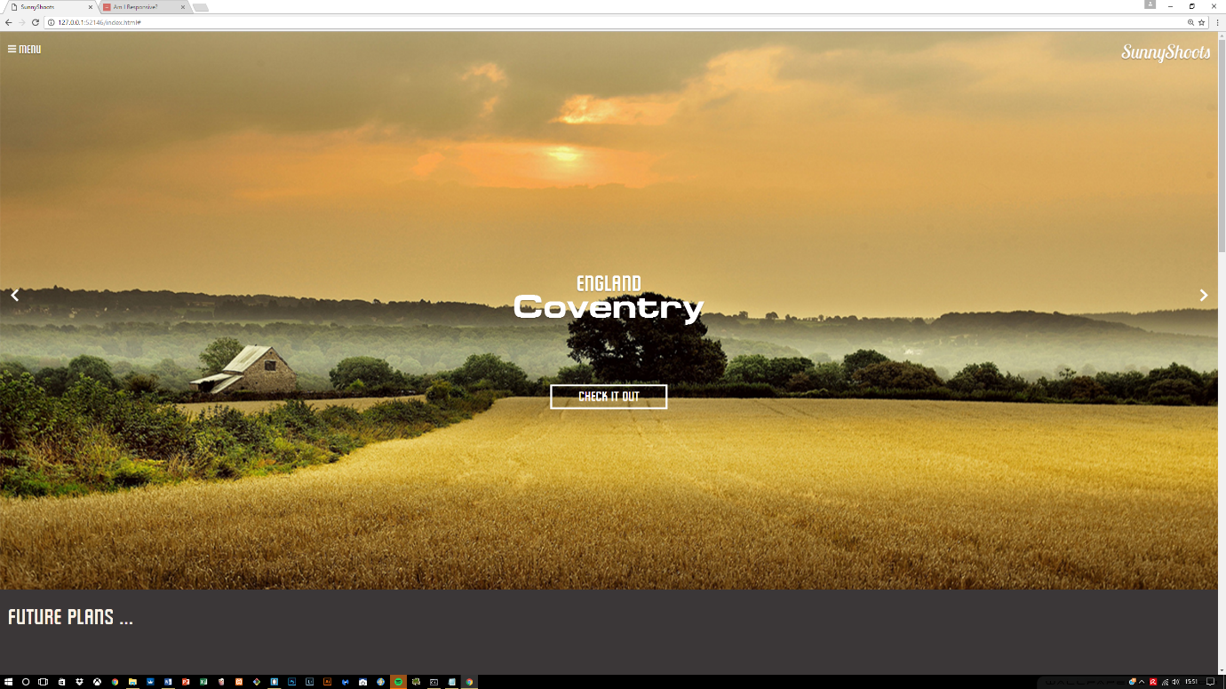With the advancement of CSS3, it provided so many benefits when it came to styling the features on the website. One of the features included hovering over the menu label and the hamburger sign transitioning in a 360 degree angle.

Other areas where this was applied included the countries section, where different countries are being presented. On this a hover effect is applied so that when hovering over the image, the image produces an overlay which is shown below:

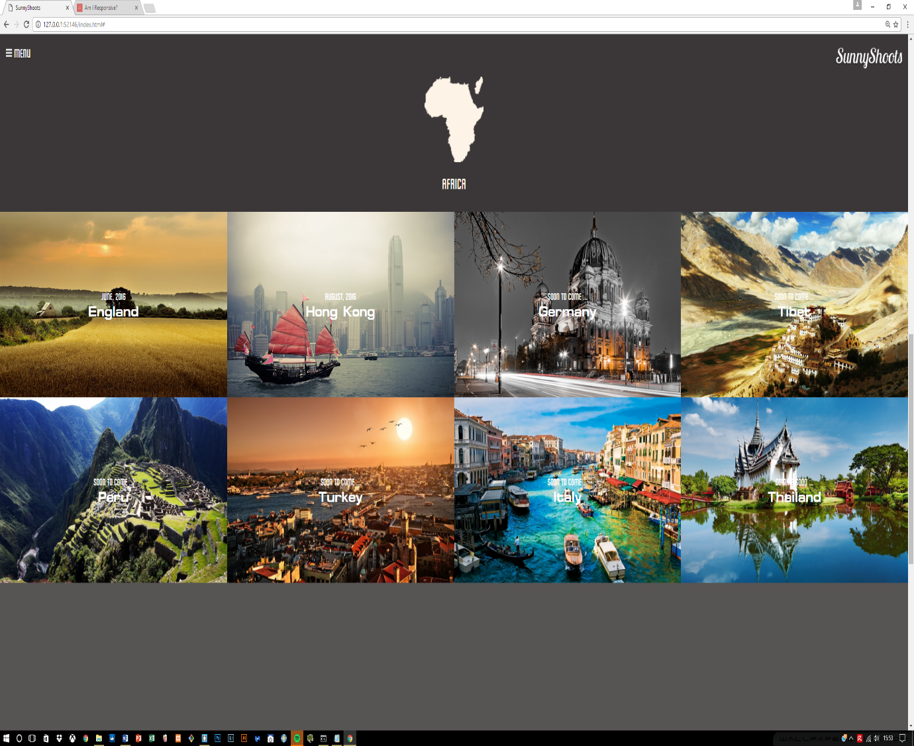

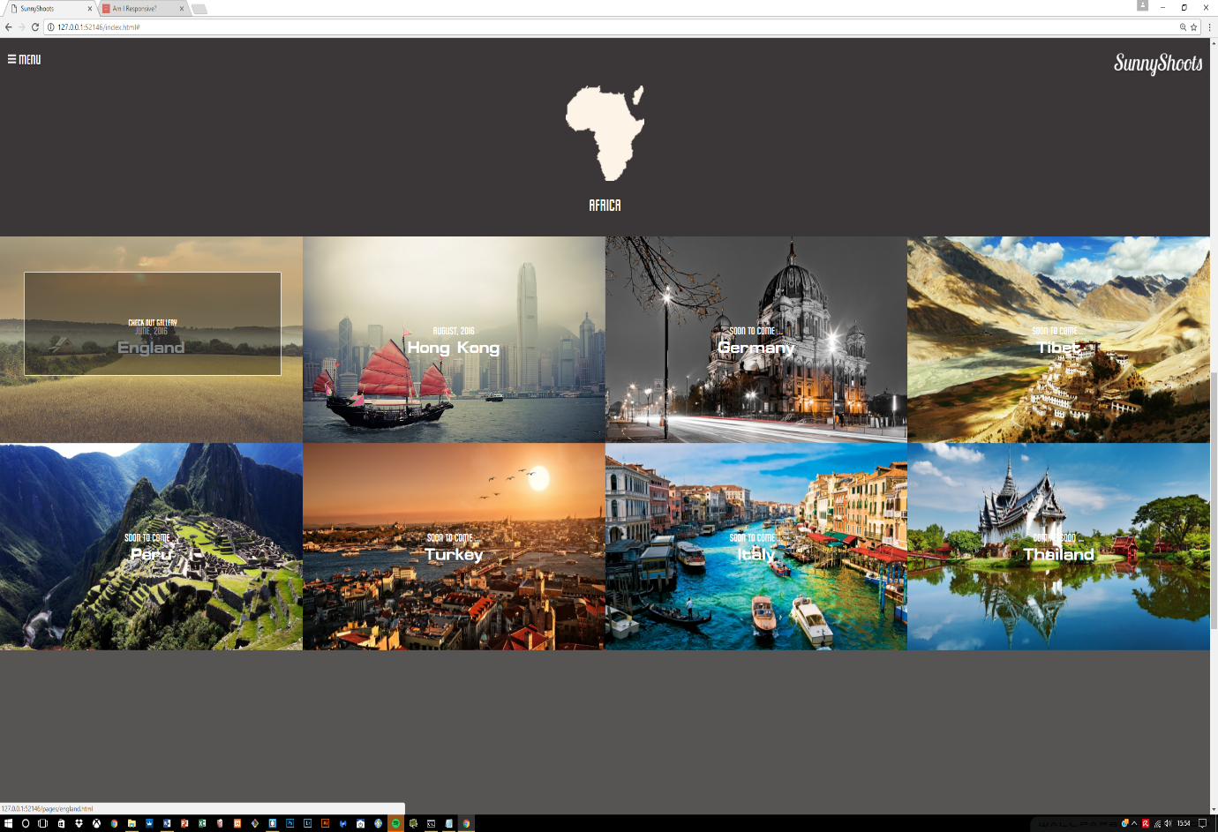

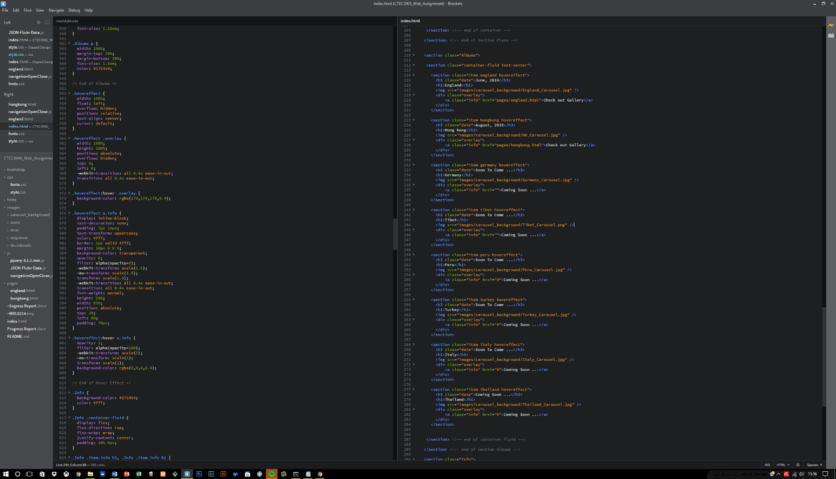This was achieved using HTML classes and CSS to contain and hide the information until required using a hover. The CSS was mainly utilised for decorating the overlay effect. The code is provided below:

**6.10 Give Background to navigation bar when reached a certain offset**

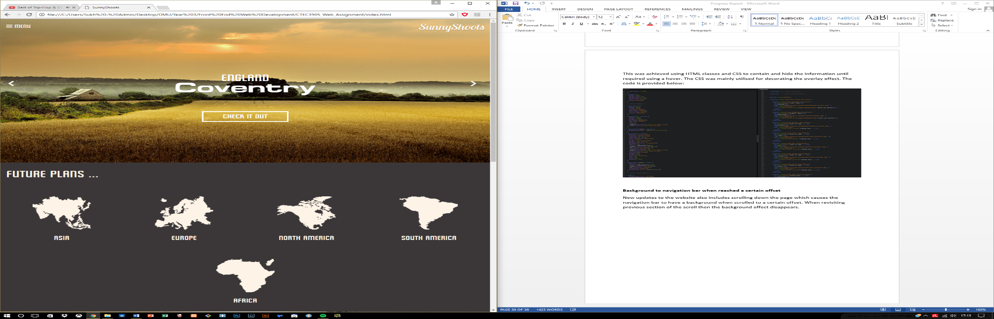New updates to the website also includes scrolling down the page which causes the navigation bar to have a background when scrolled to a certain offset. When revisiting previous section of the scroll then the background effect disappears.

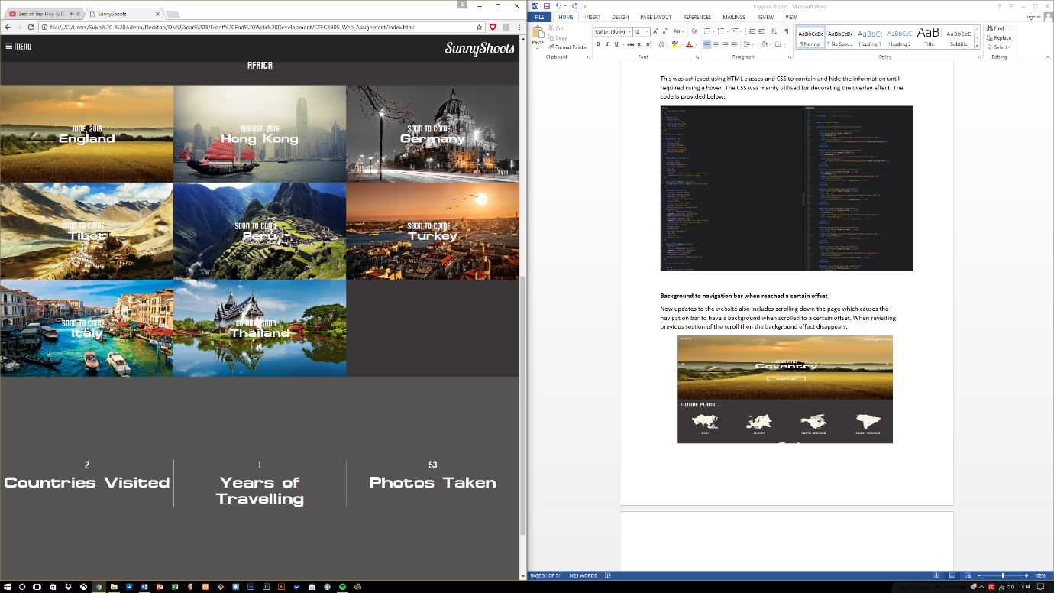

**6.11 Content in first section animated**

When the page is loaded or a new slide is visited, the content on the 1st section gets animated which creates a lively atmosphere to the entire site.

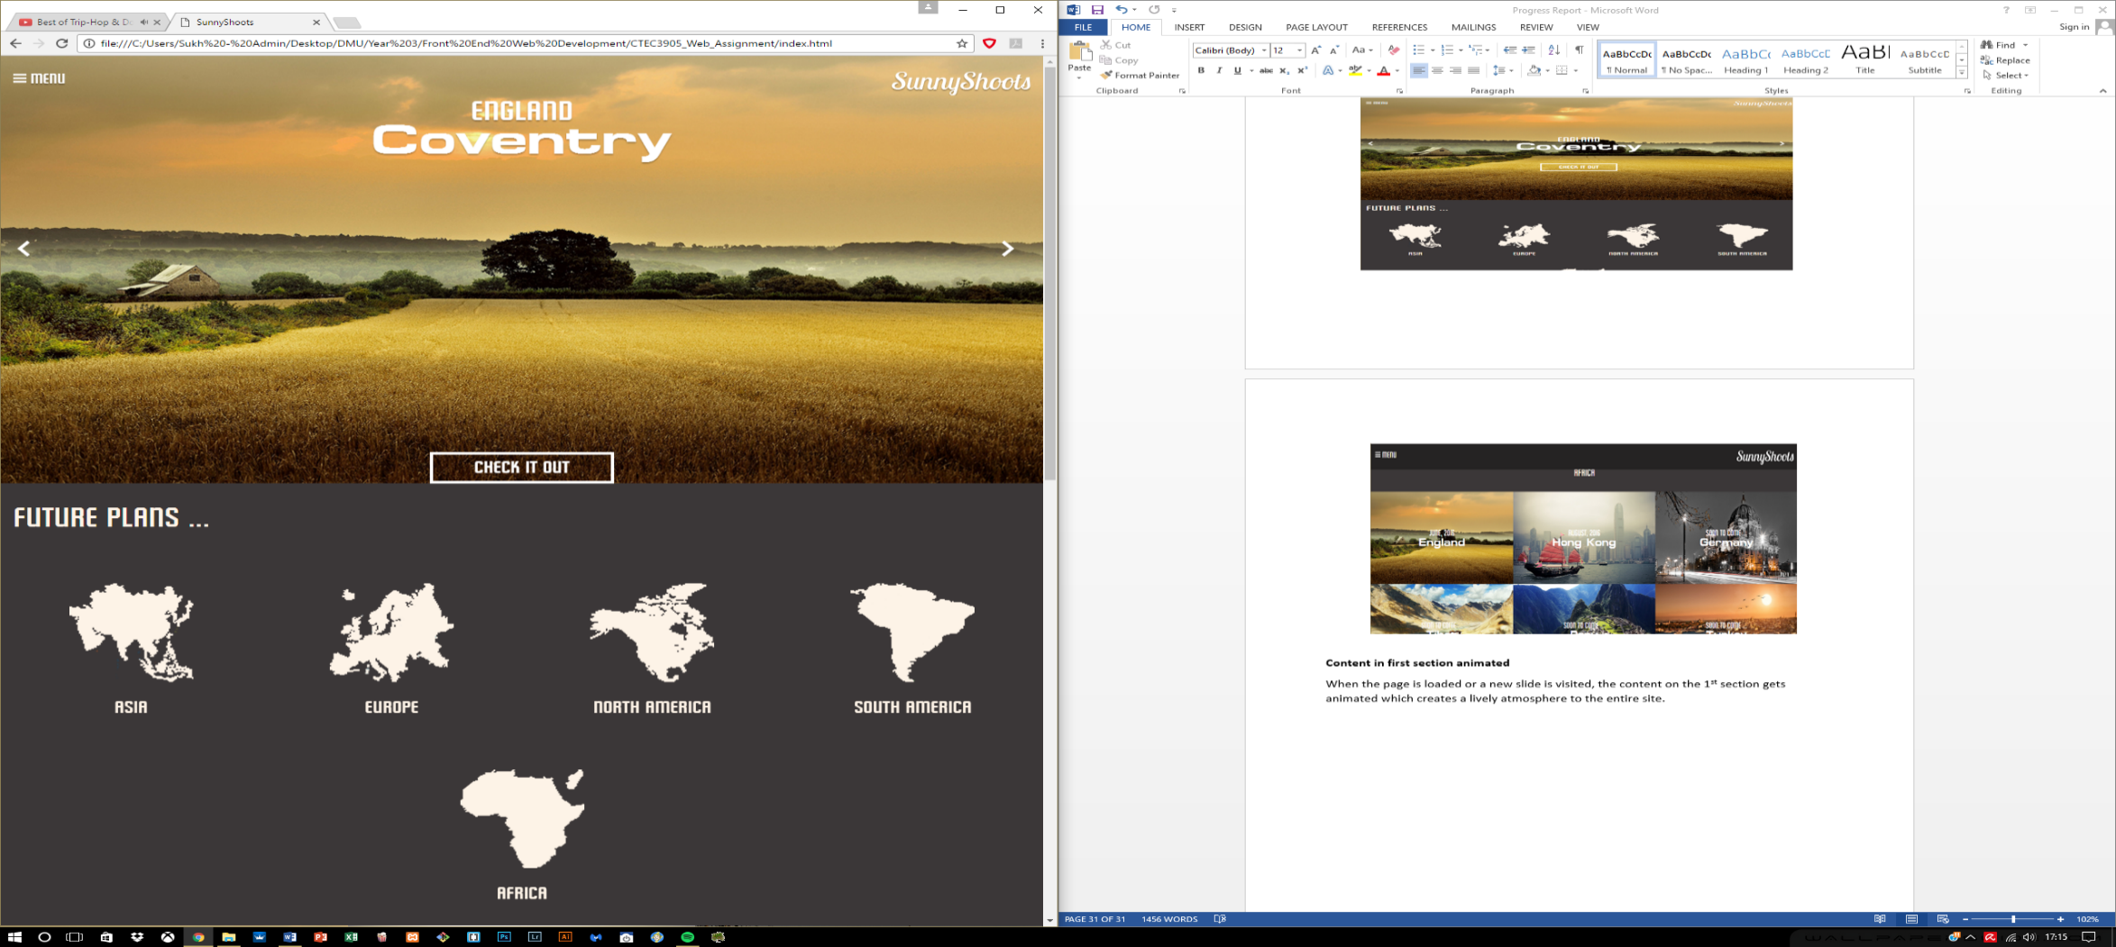

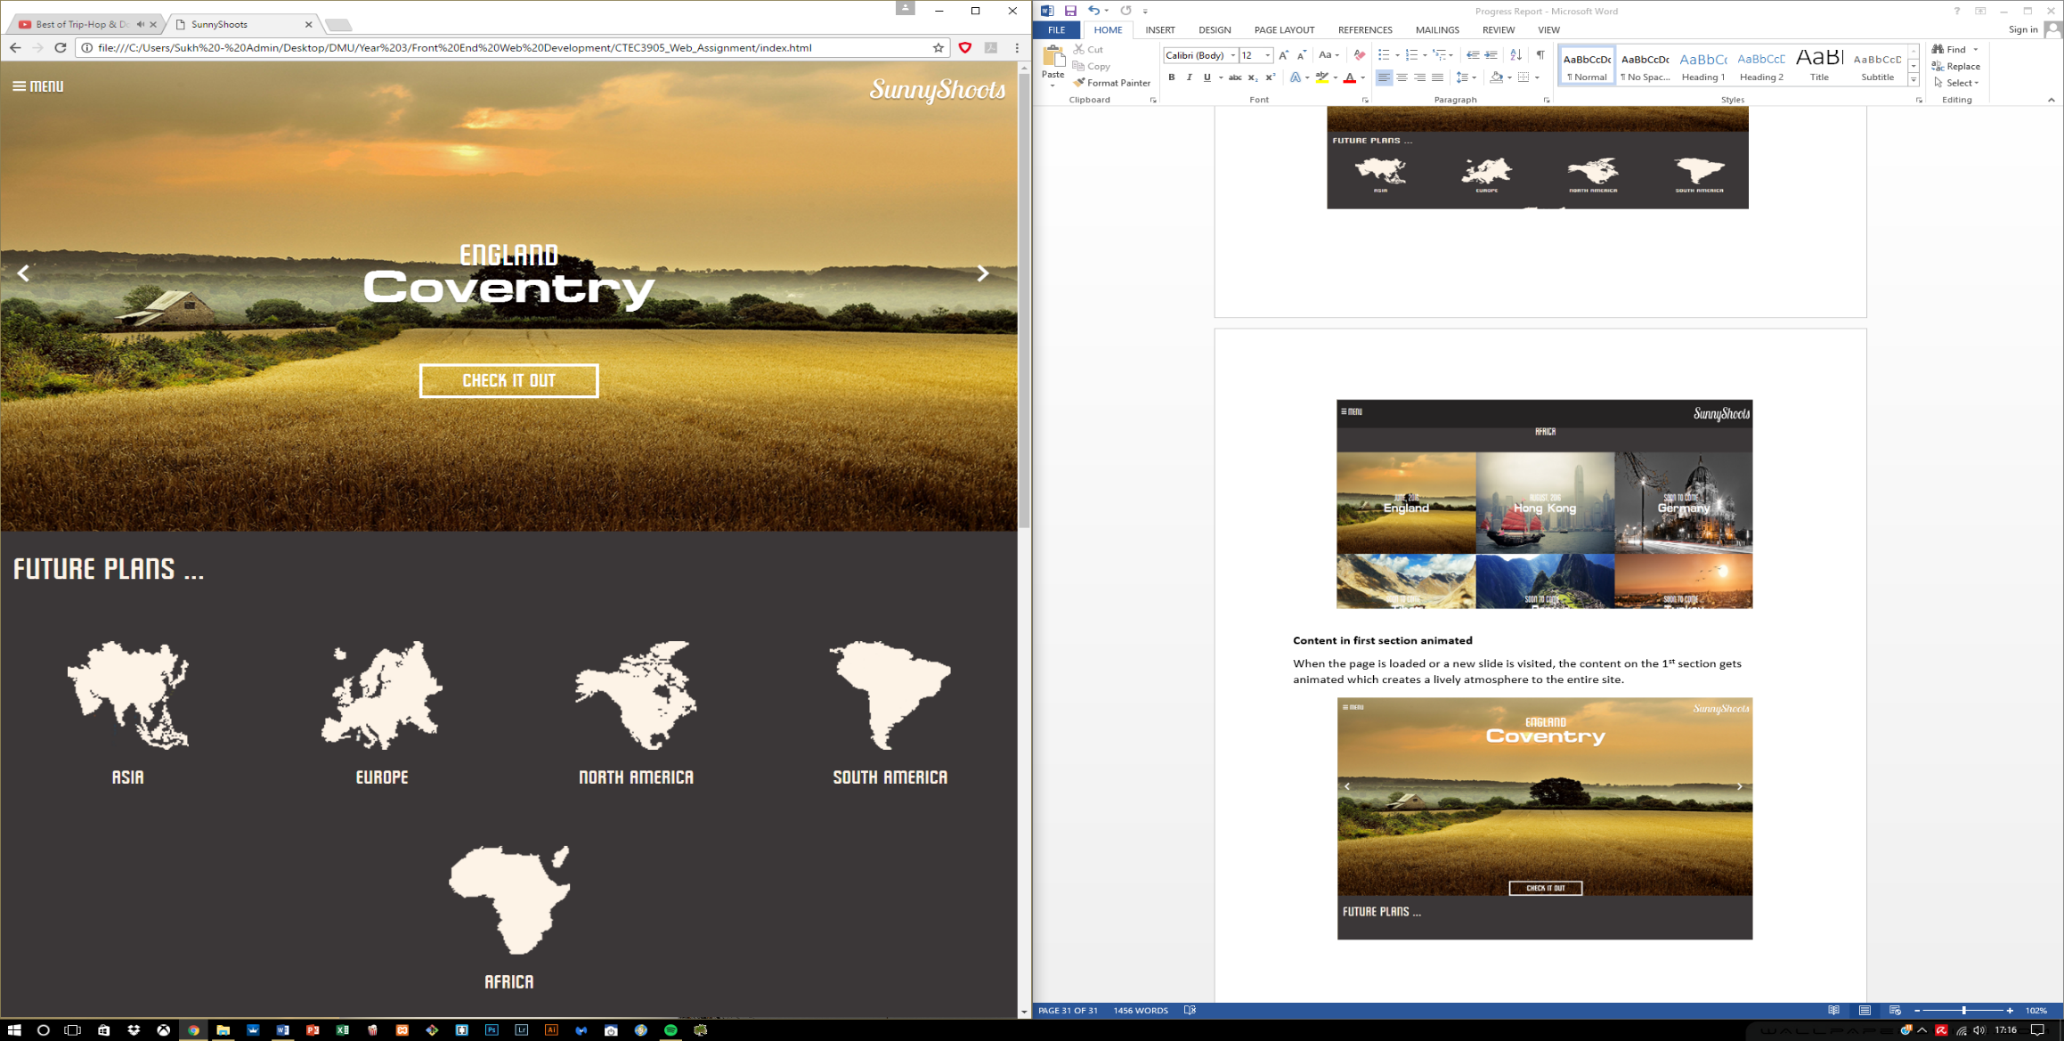

**6.12 Slider**

The slider part has also been added, but due to the layout of the structure not many animations can be done to the individual content that is being displayed within the slider. Therefore a simple animation was added to make it appear more interactive. The sliding however works perfectly in terms of selecting the left or right arrow, the correct content is displayed.

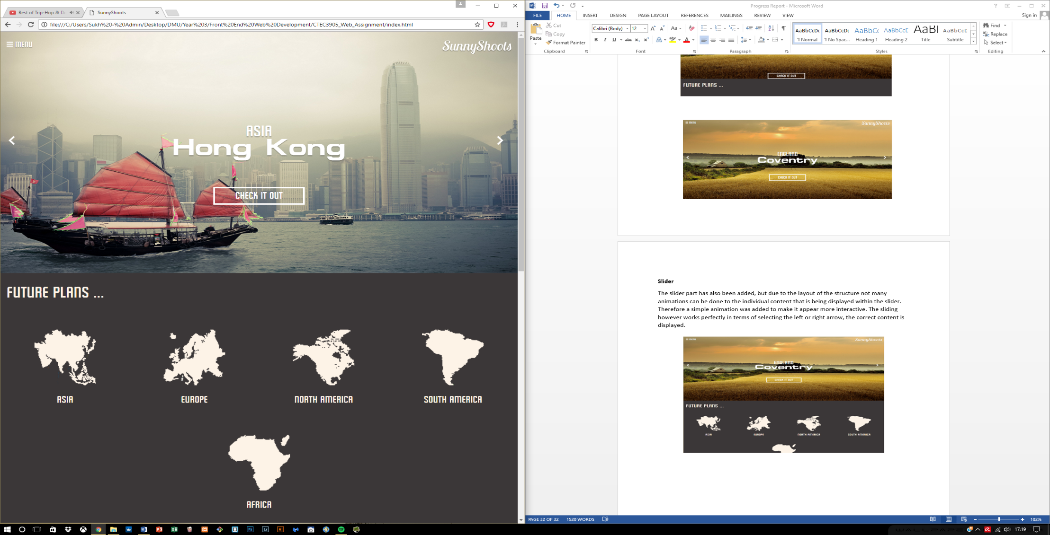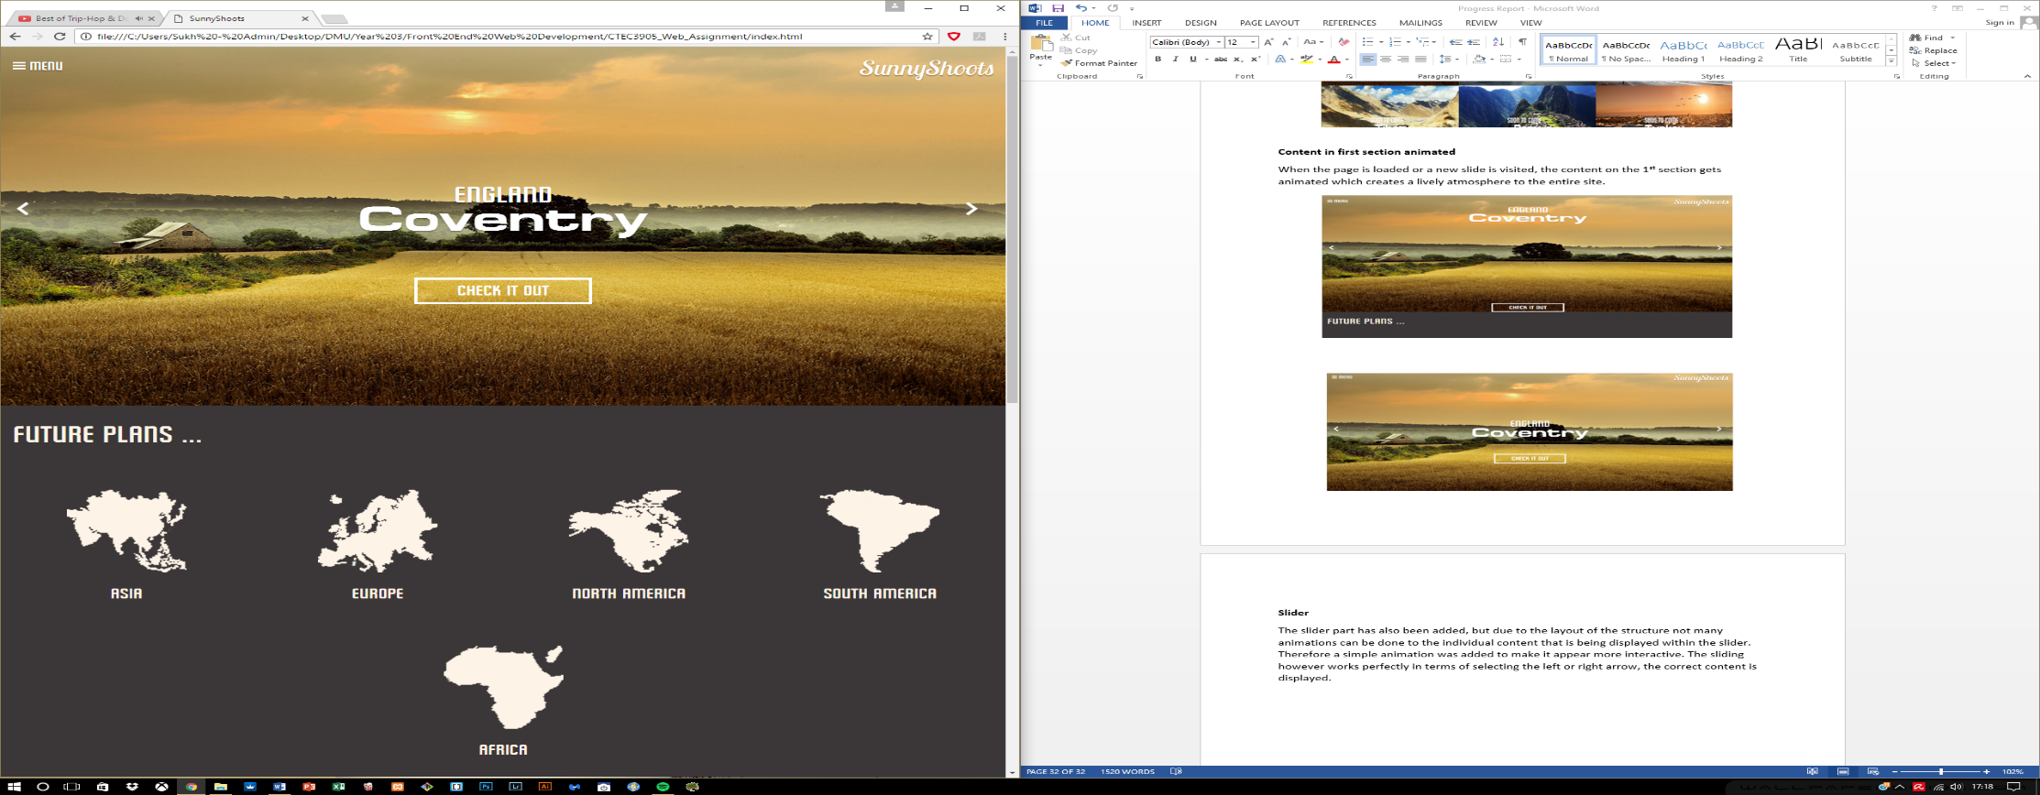

**6.13 Modal for the images**

Last feature that has been added to the current website is the Modal feature which works through the interaction with the images in one of the galleries, if the user happens to click on an image, the Modal is used for expanding the image size so the viewers can see it in an enlarged format.

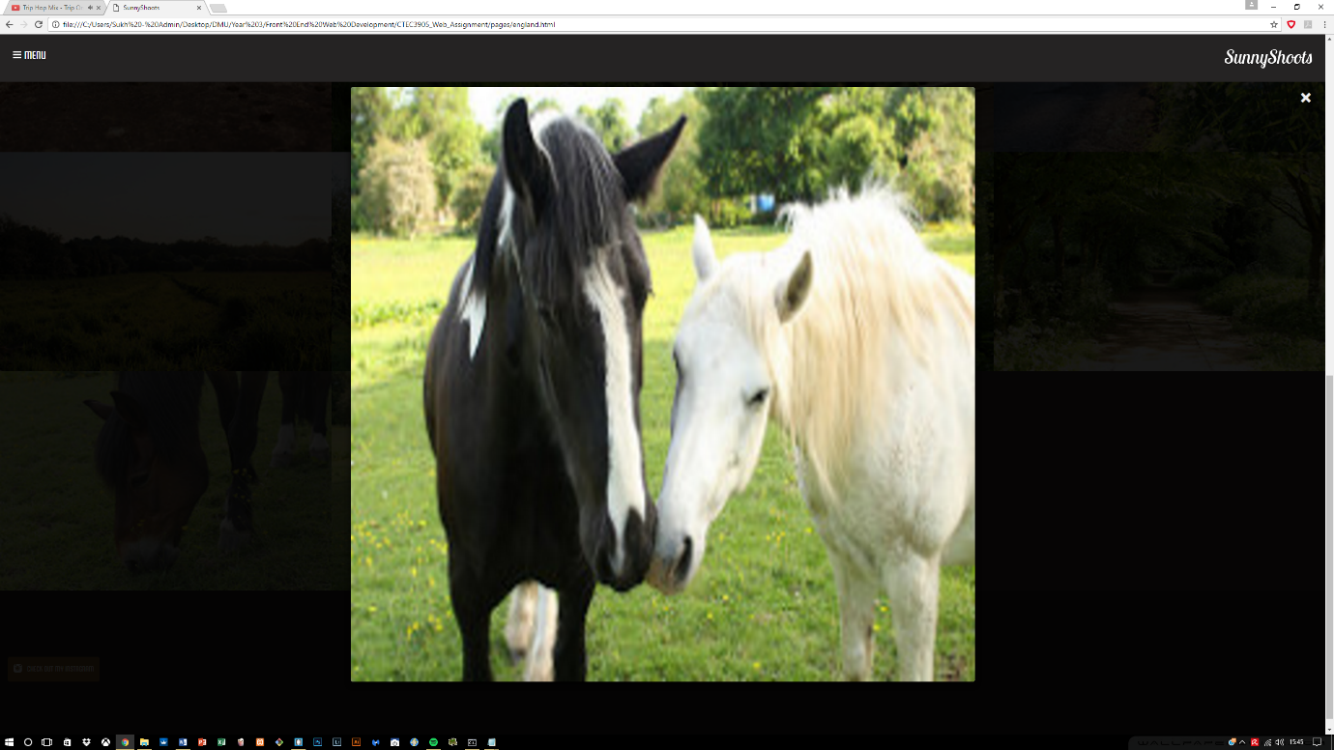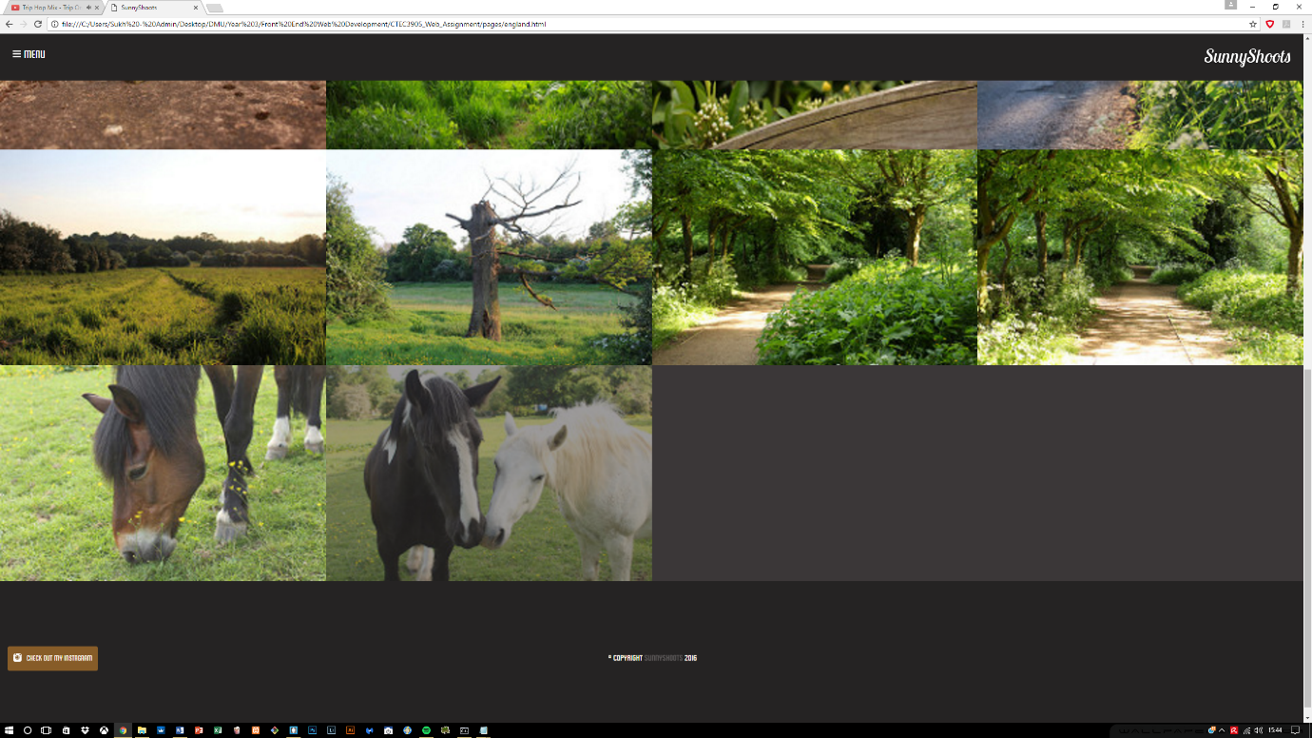This was done using with the help of JavaScript as well as creating a new structure within the HTML and utilized CSS to hide the modal until required through JavaScript.

